CURRICULUM VITAE
Personal Information 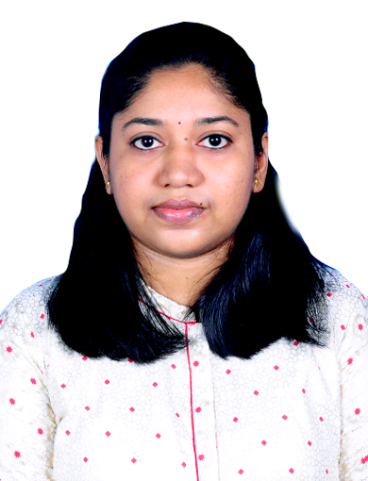
Name: Dr.Sruthi Madhusudanan
DOB: 24/01/1990
Age/ Sex: 34/ Female
Contact No: 9495279114; 7025697090
E-mail: sruthmadhu@gmail.com
Address: Flat no 206, Divyashree Apartments
Bejai-Kapikad Road
Mangalore, 575003.

Career Objective: Seeking a position as senior resident to begin my career with a reputed institution in Pathology Department.
Contributing to the fundamentals needed in growing within the academic field. Ready to utilize the teaching and administrative skills that I currently possess. Always willing to take the lead, when a leader is needed and working as part of a team.
My areas of interest revolve around teaching, research, publication and learning new updates in my field.

Educational Qualifications
Government Medical college, Ernakulam  Mysore Medical College and Research Institute, Mysore | MBBS  2008-2015  MD Pathology  2020-2023

Work Experience
Mysore medical college, Mysore  Junior Resident, Department of Pathology | 3 years experience

Achievements & Awards
- SWAYAM(ICMR)- Basic Course in Biomedical Research with score of 73
- Presented poster on CME- “KCIAPM,Synchronous Tumours: A tale of tumours”

Thesis
Topic | Guide | Co-guide | Current status (Ongoing/Published/  Presented)
“PTEN and P53 expression in a spectrum of proliferative endometrial lesions” | Dr.Shashidhar H. B | - | Completed and Accepted
Publications
- Gayathri M.N., Meghana. P., Sruthi Madhusudanan/Relevance of Mast Cell Variations in Uterocervical Lesions/Indian Journal of Pathology: Research and Practice 2023;12(3) 89–93.
Conferences Attended
- AAPUD 2021 Virtual International CME 15th to 17th July 2021
- 48thAnnual Conference of KCIAPM ,KAPCON 2021 Virtual Conference from 1st to 3rd October 2021
- CME on Recent updates in Colorectal Carcinoma JJM medical College Davangere on 7 th April 2022
- International Pathology Colloquium First edition Bhaarath Medical College and Hospital ,Chennai from 21st to 23rd April 2022
- CME on Clinical Hematology –an update on 23rd September 2022 at Hassan Institute of Medical Sciences,Hassan
- COAG PATH National CME on 5th November 2022 at JSS Hospital Mysuru
- CME and wet workshop on Hemoglobinopathies on 24th November 2022 at Mandya Institute of Medical Sciences,Mandya
- Cytology CME ‘Little is a Lot-lil' on 3rd June 2023 at Yenepoya Medical College ,Mangalore
Languages known
English,Malayalam,Kannada
Core Competencies
- Research and implementation
- Management
- Leadership quality
- Event organizing with interpersonal and team relations
Key Skills
- Good communication skills
- Experience of working with public
- Compassion towards patients
- Ability to work within clear policy of confidentiality
- Always punctual and ahead of time
- Neat and legible documentations of findings
- Flexible and adaptable to newer conditions
- Quick learner and positive attitude

Declaration
I hereby declare that the information furnished above by me is true to the best of my knowledge and belief, that has nothing been concealed

