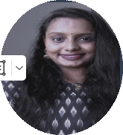

**REFERENCE**

**LANGUAGES**

**Cardio Pulmonary Resuscitation and Usage of Defibrillator**

**Advances in Ultra Sound Guided Regional Anaesthesia**

English

Malayalam

Tamil

Hindi

Kannada

Dr praveen kumar

Head of clinical pharmacologist

[Drpraveen.kumar@asterhospital.com](mailto:Drpraveen.kumar@asterhospital.com)+91 90361 13199

**TRAINING PROGRAMS**

🌢 Kulathichira, Pallipuram

pin code: 688541

✆ +918921970231

🖂 **sukanayakamalattech@gmail.com**

**CONTACT DETAILS**

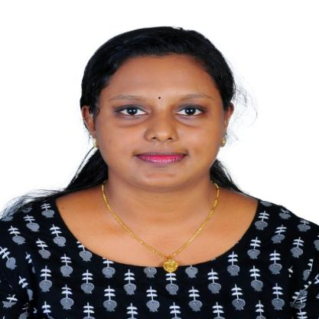

**SUKANYAMOL K K**

ANAESTHESIA TECHNOLOGIST



Anaesthesia Boyle’smachine,Anaesthesia Work Station ( DRAGER,SPACE LAB,OHMEDA),Multi-Channel Monitors ( SPACE LAB, DATEX OHMEDA, PHILIPS,BPL, SCHILLER). Bair Hugger Warming,Fluid/ Blood Warming System- Hot Line Machine ,Laryngoscope, Fibro Optic Bronchoscope, True view Scope,Storez Video laryngoscope,Ventilators- Extent, Servo, Dragger, Philips,Syringe Pumps, Infusion Pumps. USG,Machine,Nerve,Locator,Nerve,Stimulator.Defibrillators,ABG Analyzer,Suction Apparatus,Cardiac Output Monitor,Hemotherm,PA Monitor,IABP Machine.

**SKILLS**

* **BSc Anaesthesia Technology 2021-2024**

**Aster CMI Hospital (NABH Accredited) Bangalore - India**

Rajiv Gandhi University of Health Sciences.

* **Diploma In Anaesthesia & Critical Care Technology 2017-2019**

**LISIE Medical Institution Ernakulam Kerala (NABH Accredited)**

Christian Medical Association  of India (CMAI)

* **Higher Secondary 2017**

**SNHSS Sreekandeswaran Poochakkal**

Kerala Board Of Higher Secondary Examination

* **SSLC 2015**

**St.Mary’s GHS Cherthala**

Kerala Board Of Public Examination

**EDUCATION**

To enhance my professional skills, capabilities and knowledge in an organization which recognizes the value of hard work and trusts me with responsibilities and

challenges.

**PERSONAL SUMMARY**

**Anaesthesia Technologist**

* Aster CMI Hospital (NABH Accredited) Bangalore - India

Internship Training Feb-2023 - Feb-2024

* Lisie Hospital, Cochin, India Sep-2019-Feb 2021

1 Year & 5 Months Experiance

**WORK EXPERIENCE**