MARY NISHA V J | 6282073737  E-mail: marynisha25@gmail.com

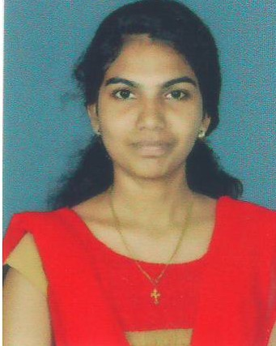

OBJECTIVE

Contribute to a dynamic growing organization where my strong analytical, interpersonal skills and hard work will have a significant impact. The optimal position will provide professional growth and opportunities to contribute.

EDUCATIONAL QUALIFICATIONS

Course | Institution | Year of Passing
B.Sc. (Zoology) | Cochin College, Kochi | 2017
Plus Two (Science) | GHSS Puthanthodu | 2014
S.S.L.C. | St.Mary’s HS Chellanam | 2012

OTHERQUALIFICATIONS

- Diploma in Co-operate Accounts & Taxation with SAP
- Diploma in Microsoft Excel and Microsoft Word

WORK EXPERIENCE

- 4 years worked in Kendriya Vidyalaya No.2 Naval Base, Kochi as Data Entry Operator.

PERSONAL DETAILS

Date of Birth | 03/09/1996
Gender | Female
Nationality | Indian
Religion | Christian
Marital Status | Married
Husband’s Name | Abel George
Permanent Address | Kurishingal (H) Azhikkal PO, Vypin
Language Known | Malayalam and English

Date:16.04.2024
Place: Vypin Mary Nisha V J

