GOKUL T S
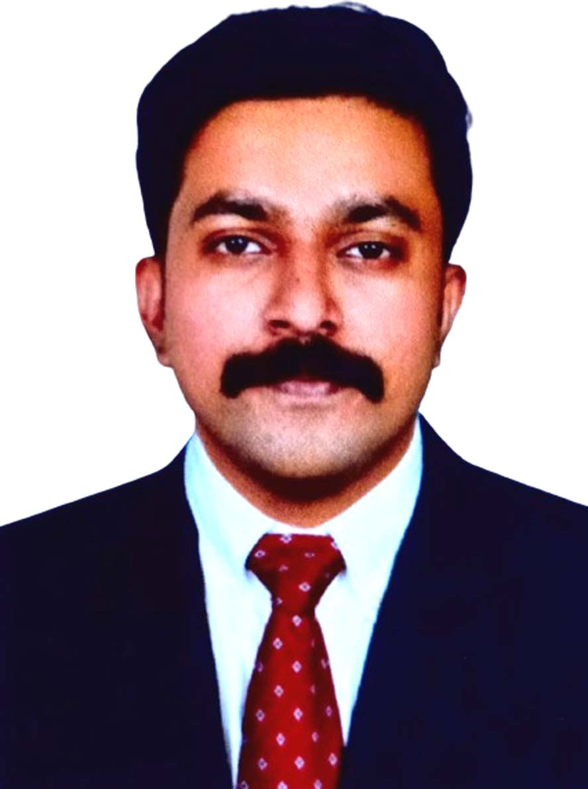

Personal Info

Date of Birth : 27.12.1994
Gender : Male
Father's name : Suresh T V
Mother's name : Sheena Suresh
Nationality : Indian
Marital Status : Single
Blood Group : B+Ve

Medical Transcriptionist
Email: t.sgokul12@gmail.com Mobile: +91 811982777

Professional Summary

Objective

“Obtain a medical transcription position where my abilities will contribute to the smooth running and success of the organization”

- Working as Medical Transcriptionist from 2 years on medical transcription based platforms on UAE transcription and 1 year as a Quality Documentation Specialist under Nuance. Skilled in Electronic Medical Records (EMR), Quality assessment of coded data.
- Ability to generate discharge summaries, medical history and physical exam reports, operational reports, consultation reports and progress notes.
- Expertise in the use of medical terminology to accurately communicate diagnosis or treatment, translate medical abbreviations and lingo, refer to standard medical reference documentation for clarity
- Follow specific standards applicable to medical record style and legal and ethical requirements to keep patient information confidential.
- Exceptional ability to interpret, recognize and assess divergences and inconsistencies in medical texts.

Experience

07/07/2022 - Present
DYNAMED HEALTHCARE SOLUTIONS
Medical Transcriptionist
Infopark, Ernakulam, Kerala, India.
- Demonstrated strong knowledge of medical terminology and anatomy.
- Demonstrated extremely fast and accurate typing abilities.
- Dictation by physicians and other healthcare professionals on electronic medical reports (EMR)
- Conversion of dictated audio into electronic medical reports (EMR) format by placing the chief complaints, severity, associated symptoms, history, physical examination, and the dictated file into each section using SAP software.
- Fill out the risk table for further coding purposes after evaluating the patient's diagnosis and condition.
- Processing the files within 24 hours for further procedures and for follow-up purposes.
- Examine the patient lists and report any missing patients who were not dictated by the provider.
- Lab values and medication are double checked with reports provided by the physician with the dictated audio file.
- Make corrections to grammar, spelling, and syntax when needed.
- Transferred transcribed materials in to an electronic health record system.

22/02/2021 to 12/03/2022
CONSCIENCE BUSINESS SOLUTIONS
Quality Documentation Specialist
Technopark, Thiruvananthapuram, Kerala India
- Experienced Medical Scribe with a proven track record of accurately documenting patient encounters, transcribing medical histories, and assisting healthcare providers with administrative tasks.
- Proficient in Electronic Health Records (EHR) systems and adapt at maintaining confidentiality and professionalism in fast-paced clinical environments.
- Skilled in multitasking and communication, facilitating efficient patient care delivery.
.
Skills
- Extensive knowledge on anatomy & physiology
- Maintains strict confidentiality
- Quality assessment of coded data
- Typing speed(50-wordsperminute)
- Team player with a positive attitude
- Deadline-driven
- Transcription
- Patient histories
- Multitasking
- Perfectionism
- Commitment to Learning
- Leadership skills

Education

- Electronic medical records
- Reporting skills
- Strong work ethic
- Document quality
- Time management skills.
- Patient-focused care
- Strong listening skills.
- Fast and accurate typing skills.
- Entertaining skills
- Ability to understand medical terms
- Discipline
- Teamwork

2020 – Certified Programming Medical Scribing

2010 – Higher Secondary-Bio- Maths (66%) R M H S S Aloor

2012

2010 – High School (84%) R M H S S Aloor

Hobbies

- Dancing
- Watching Movies
- Time spent with my families
- Reading
- Listening Music

Languages
- Malayalam-Native
- Hindi
- English
- Urdu

Software Skills
- Electronic Medical Record(EMR)
- SAP software(medical)
- MSOffice
- MS Excel

