CURRICULAM VITAE
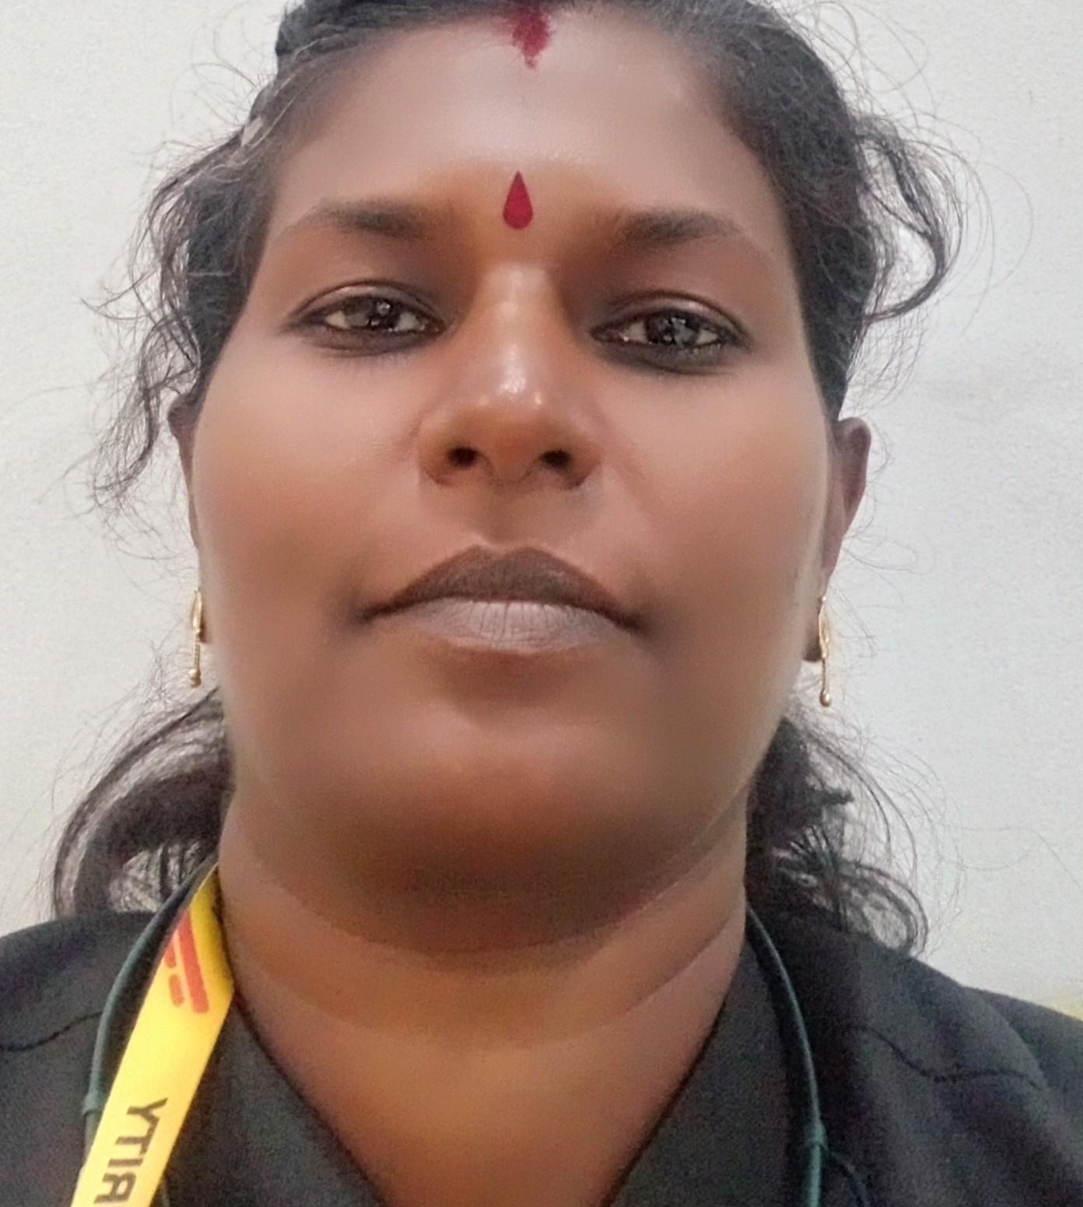

SALINI K V
VATTAPARAMBIL SIVAPRIYA NIVAS
CHOTTANIKKARA (P.O)
CHOTTANIKKARA
ERNAKULAM (DT)
Email ID:Salusubhash2007@gmail.com
Contact no: 9947134521/9744258558.

CAREER OBJECTIVE

To accomplish my career skills in Computer application, thereby deriving job satisfaction, as well as contributing to the excellence and peak performance of my employer establishment, from my part.

EDUCATIONAL QUALIFICATIONS

- B. Com in Co-operation from M G University, Kottayam.
- Pre Degree in Commerce Group from M G University, Kottayam.
- S.S.L.C from the Board of Public Examinations, Kerala State
COMPUTER KNOWLEDGE
- MS Office, Excel, Internet, DCFM (accounting package),Tally 9.
WORK EXPERIENCE

- 1 and a half years experience as Accounts Executive in Charutha Silks & Ready Mades,Tripunithura.(Excel,Word,Internet & Tally)(10.04.2013 t

- 2 years experience as System Operator cum Office Clerk at Nirmala Arts & Science College Mulanthuruthy.(Excel, Word, Internet & Tally 9)(02.02.2015 to 05.04.2017).

- 2 years experience as Accounts Assistant at Sterlng Gases Ltd Ambalamugal.(Excel,Word,Internet & Tally)(19.06.2019 to 19.06.2021) on contract base.

- 1 year experience as Security Supervisor at Milma Tripunithura.(01.01.2023 to 29.02.2024)

Personal Details
Age &Date of Birth : 43 years, 06.04.1981
Gender : Female

Religion & Caste : Hindu, Vilakkathala Nair.
Marital Status : Married
Husband’s Name : Subhash K Balan

Children : 2
Nationality : Indian
Languages known : English, Malayalam
Declaration
I hereby declare that all the information stated above is correct to the best of my knowledge and belief.

Place: CHOTTANIKKARA.
Date: SALINI K V

