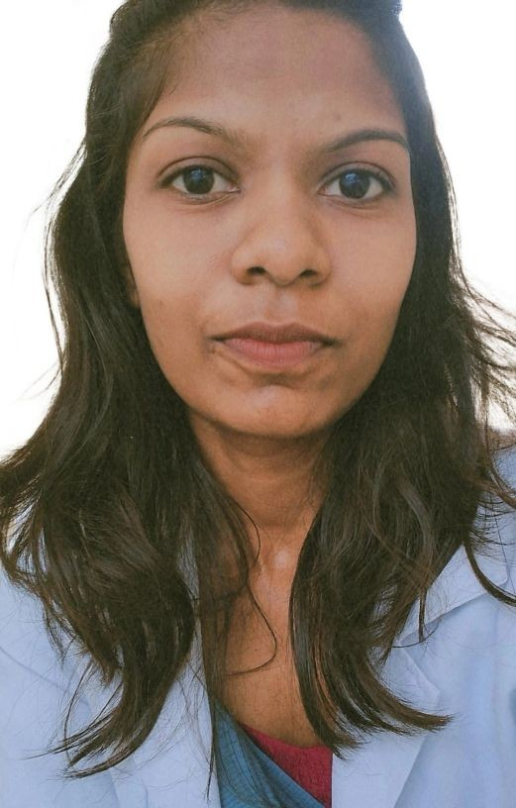
Kesia shajan
vattapparambil (HO) kokkappilly (PO)Thiruvaniyoor Ernakulam
682305
kesiashajan123@gmail.com
9744065033
24/01/2001

Objective Provide effective nursing care for maintaining best possible level of health in all aspects. Promote self care in people under their care. Apply problem solving techniques in nursing practice.
Apply knowledge from the humanities, biological and behavioural science in functioning as a nurse.

Personal

DETAILS
Date of Birth :24/01/2001 Gender : Female
Marital Status : Single
Religion : Christian Father's Name : Shajan VS
Mother's Name :Nisha shajan

Language English Malayalam
Tamil

Education Rev. Noorunnissa college of nursing, kolar, kgf, under RGUHS, Bangluru, Karnataka
Bsc Nursing -

ST. Joseph CGHSS Thripunithura
HSE -

ST George's HSS Vennikulam
SSLC -

Experience clinical practices done in General Hospital, kolar, Kgf and KC Hospital Kuppam
* Monitoring vitals
*IV cannulation/SV
*Injections(IV, IM, ID)
*wound care & dressing
*supportive care

Skills
*Monitoring of vitals
*Administration of medications
*IV cannulation/SV
*Injections (IV, IM, ID)
*wound care & dressings
*supportive care
*Coordination of work

Deceleration I here by declared that all statements are true, complete and correct to best of my knowledge and belief. place:

Date:
KESIA SHAJAN

