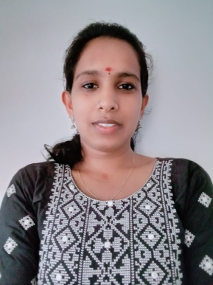
SHILPA SELVAN

CONTACT DETAILS

Mobile Number:
+91 7902279319
E-mail Address:
Shilpaselvan125@gmail.com

PERSONAL DETAILS

Languages Known
English, Malayalam

Date of Birth
03-11-1999

OTHER DETAILS

- Father’s Name: Selvaraj P
- Sex: Female
- Passport: B8382185
- Marital Status: Single
- Nationality: Indian
- Permanent Address:
Shilpa Selvan,
Pazhayampilly (H), Assarikkad P.O Murikkumkundu, Thrissur, Kerala, 680751

CAREER OBJECTIVE
To work in a medical facility where my nursing profession is an advantage in catering quality health care and humanitarian services to its general clientele. To seek a nurse position where a professional along with personnel skills can help maximize spiritual growth in the service of God and humanity, in dedication to my work.
responsible position.

SUMMARY OF QUALIFICATION
- Possess excellent communication, interpersonal and leadership skills
- Quick learner with an ability to easily assimilate new ideas, concepts, methods and technology
- Remain calm and professional throughout critical incidents
- Develop rapport with the clients, family, staff, and physicians
- With strong managerial skill
- Ability to work effectively
- Strong quantitative and analytical skills
- Very much willing to learn, versatile, dedicated, competent and self-motivated team player/builder
- Willing to extend knowledge in the field of nursing

EDUCATIONAL QUALIFICATIONS

- B.Sc. Nursing, Kerala university of health and science, Aswini college of nursing, Nadathara, Thrissur, REG NO: KL03202306308

- Higher Secondary Education (HSE) In Biology Science,
Govt Model Boys School, Thrissur (2015 – 2017)

- Secondary School leaving Certificate
St Sebastian’s HS Mannamagalam (2015)

DUTIES & RESPONSIBILITIES

- Assessing , observing, and speaking to patients
- Recording details and symptom of patient medical history and current health
- Preparing patients for exams and treatment
- Administrating medication and treatments, than monitoring patients for side effects and reactions
- Assisting in medical procedure as needed

PERSONALITY TRAITS

- Confident
- Leadership
- Hard working
- Creative thinking ability
- Excellent teaching ability

- Maintained excellent attendance record, consistently arriving to work on time.

DECLARATION
I Shilpa Selvan hereby declare that the above said details are true & correct to the best of my knowledge & belief.

Shilpa Selvan

