SREEVIDYA
BSC NURSE
Thiruvonam,iverkala naduvil,iverkala east po puthoor,kollam | +91 7025647342 | Sreevidyas2000@gmail.com
 | OBJECTIVE
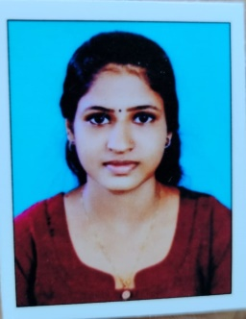
To obtain a B.Sc. nurse position which will create opportunities to expand practical experience and knowledge, while at the same time providing quality health care and discharging duties effectively.
Key skills | EDUCATION
- Patient and family management  - Stress management  - Detail-oriented  - Compassion  - Microsoft Office  - Decision Making | Bachelor of Science Nursing (October 2023)  Rajiv Gandhi University of Health Sciences, Bangalore  Higher Secondary Education (March 2019)  Kerala State higher secondary school,puthoor  Secondary Education (June 2017)  Kerala state high school,kadampanad
 | PERSONAL INFO.
Date of Birth | : | 21-06-2000
Father’s Name | : | Vinod n
Marital Status | : | Single
Languages  Religion  Nationality | :  :  : | English, Tamil, Kannada & Malayalam  Hindu  Indian

 | DECLARATION
I Sreevidya hereby declare that all the above furnished details are true to the best of my knowledge and belief.

Place:kadampanad
Date: 13-11-2023 SREEVIDYA

