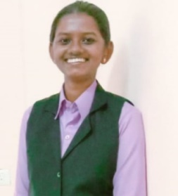DAINTES CYRIL
8078801722
daintescyril@gmail.com
SUMMRY Highly-motivated employee with desire to take on new challenges. Strong wrath
Ethic, adaptability and exceptional interpersonal skills. Adept at working
Effectively unsupervised and quickly mastering new skills. Hardworking employee
With customer service, multitasking and time management abilities. Devoted to
giving every customer appositive and memorable experience. Organized and
motivated employee eager to apply time management and organizational skills in
various environments. seeking entry-level opportunities to expand skills while
facilitating company growth. Hardworking and reliable with strong ability in.
Offering and highly organized, proactive and punctual with tem- oriented mentality.
SKILLS Organization and time management, Problem Resolution, Communication, written
Communication, Problem-Solving, Analytical, Self-Directed, Attention to Detail,
Supervision and Leadership, Microsoft word & Excel, Cultural Awareness, Planning,
Recordkeeping, Organization.
EDUCATION S.S.L.C. St: Marys Anglo Indian Higher Secondary, plus –ll G.H.S.S. Ernakulam
Under graduation St: Pauls College Klamassery in Economics, Post graduation
St: Alberts College Autonomous Ernakulam (one back paper in ll semester)
Date of birth 28-03-1999
LANGUAGES Malayalam, English, Hindi
CERTIFICATIONS Computer Certificate & International Hospital Administration
ACCOMPLISHMENTS N.S.S.& Chagathikuttam

