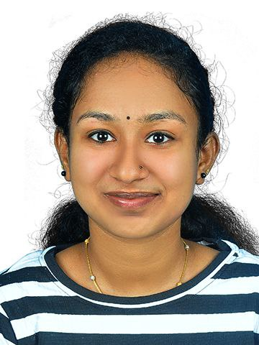 | punnya prakash  cardiac technologist
CONTACT  Thampurakazhikom  Koonayil,Paravoor PO  Kollam , 691301  9061575430,8111956102  punnyaprakas@gmail.com  Communication  I have received several awards for my outstanding communication skills, including recognition for providing exceptional patient education and counseling.  Leadership  I have been recognized for my contributions to patient safety and satisfaction in my current role | Education  Sri lekshmi Narayana institute for medical science and reserch / Osudu agaram /Pondichery  Bachelors in cardiovascular technology  Relevant course ; Anatomy ,physiology & biochemistry, pharmacology, medical physics, basics of computer, medicine relevant to cardiac technology , echocardiography, cath lab catheterization, ecg monitoring  Experience  January 2023-June 2023  Cardiac technologist / ECG ( CARDIART 9108D), Echo,TMT ( machine – schiller C S- 20)/ NS CO Operative hospital  July 2023-December2023  Cardiac technologist / catheterization lab (C arm machine – Phillips AURIZON 3 M 15) / NS CO Operative hospital  I have a proven track record of delivering high-quality care while maintaining patient safety and satisfaction  References  [Available upon request]

