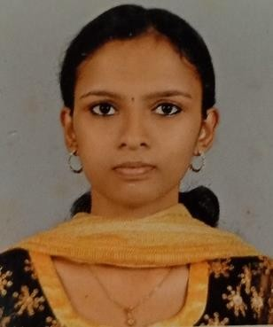
ARCHANA V. S
Vairamala Thakadiyil (H), Vazhoor P.O,
Kottayam, Kerala,
India - 686504
- achuarya97@gmail.com
+91 9074187085,
+91 8281820739.

Objective
Talented optometrist with strong commitment to service in the optometry field. Passion for helping others to solve vison problem and improve the quality of life. Friendly and caring healthcare provider with excellent customer care service

Education and Qualification

Course | Institution | Board/university | Year of passing | Percentage
MSc. Optometry | Ahalia School of Optometry and Research Centre | Kerala University of Health and Science | Currently perceiving
Bsc.  Optometry | Al Salama College of Optometry | Kerala University of Health and Science | 2022 | 73%
HSE | MGM NSS HSS  Lakkattoor | Kerala State Board | 2016 | 91.25%
10TH | Aravinda Vidya Mandiram, Pallikkathodu | CBSE | 2014 | 88%

Internship

- Al Salama College Of Optometry

Projects
- Prevalence of hypermetropia and presbyopia between the age group of 35 and 70
- Types of corneal ulcer in perinthalmanna
- Effect of cosmetic coloured occasional wear soft contact lens on goblet cell density count and pH : A case-control study.

Personal Skills
- Effective patient care and management
- Teaching skills
- Adaptive to changes
- Language skills
- Basic computer skills
- Self creativity
- Emotional Intelligence
- Integrity

Professional Skills
    - Subjective and objective refraction
    - Squint and orthoptics evaluation
    - Contact lens fitting and management
    - Ocular pharmacology
    - Training and teaching
    - Dispensing and IPD marking
    - Biometric and perimetric procedures
    - Lasik evaluation and counseling
    - Low vision evaluation and dispensing
    - Retina department
    - Currently perceiving BA (Hons.) Psychology from Indira Gandhi National Open University(IGNOU)
    - Non strabismus anomalies evaluation, assessment and dispensing
    - Orthotec management of amblyopia
    - Amblyopia management and therapy

Pratical Skills

- Subjective and objective refraction
- Slitlamp examination
- Perimetry (HFA)
- A –Scan
- Keratometry
- Tonometry
- Specular microscopy
- Lensometry
- Fundus fluorescein Angiography
- Low vision and management
- Geriatric refraction and dispensing
- Tonometry
- Contact lens
      - Soft contact lens fitting, assessment
      - Soft toric fitting and assessment
      - RGP fitting and assessment
      - Scleral fitting and assessment
      - Rose K-Fitting
      - Cosmetic contact lens fitting, assessment and dispensing
- Orthoptics

      - Cover uncovet test
      - Worth four dot test
      - PBCT
      - Maddox rod
      - Maddox wing
      - NPC
      - AF Ruler
      - TNO test
      - Timus fly test
      - Bagolini straited glass
      - Accommodative and convergence flipper

Achievements
- Conducted and participated in 'AALA 2022' at Al Salama Eye Hospital Perinthalmanna
- Presented several seminars and synopsis at Al Salama College Of Optometry
- Attend several eye camps and screening programs

Language Proficiency
- English
- Malayalam
- Tamil
- Hindi

Declaration
I here by certify that all the above information that I provided here is true to the best of my knowledge and belief.

Date:

Place: ARCHANA V.S

