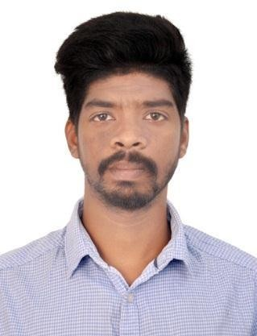
EMMANUEL A.F.
Nationality: Indian
(+91 ) 8943811266
Email address: pradeepepf@gmail.com
Whatsapp Messenger : 8943811266
Address: ARAKKAL HOUSE, KANNAMALY P O, KOCHI, 682008ERNAKULAM
(India)
Date of birth: 15/08/1996
Gender: Male

WORK EXPERIENCE

ELECTRICIAN AND OPTICAL FIBR TECHNICIAN

ASIA VISION NETWORK COMMUNICATION THOPPUMPADY (21/03/2022-Current)

City: KOCHI

Country: INDIA

EDUCATIONAL QUALIFICATIONS

- SSLC

- PLUS TWO

- ITI ELECTRICAL (NCVT)

TECHNICAL QUALIFICATIONS
ITI ELECTRICAL COURSE (NCVT)
[ 2019-2022 ]
BLUETRONICS ENGINEERING INSTITUTE., KOCHI, ERNAKULAM

LANGUAGE SKILLS

Mother tongue(s): MALAYALAM
Other language(s):

English
LISTENING A1 READING A1 WRITING A1

SPOKEN PRODUCTION A1 SPOKEN INTERACTION A1

Hindi
LISTENING A1 READING A1 WRITING A1

SPOKEN PRODUCTION A1 SPOKEN INTERACTION A1

DIGITAL SKILLS

Social communication and platforms / Internet, E-mail and Social Media / Experience in video conferencing / (Zoom, Skype)/ Configuration (Modam , OLT)

COMMUNICATION AND INTERPERSONAL SKILLS
- Skills

Hardworking

- Motivated
- Good Attitude & Communication
- Knowledge about Optical fiber
- splicing and electrical

PASSPORT DETAILS
Passport
- Passport No : T3125912
- Date of Issue : 04.02.2019
- Date of Expiry : 03.02.2029
- Place of Issue : COCHIN

