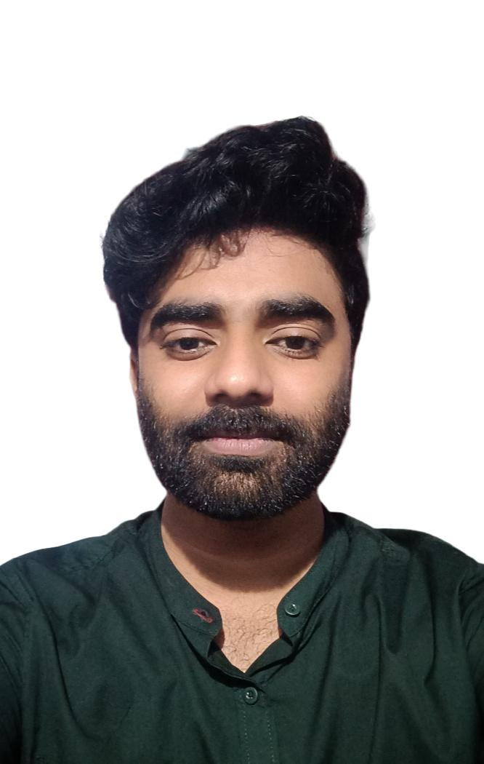
PETER TINIL N.J
BSc. Cardiovascular Technology
+91-9846215151

tiniljoseph1999@gmail.com

CURRICULUM VITAE

OVERVIEW

- Seeking an Entry-level career as a Cardiovascular Technologist in a reputed healthcare establishment
- To take responsibilities as a professional with a progressive and professionally managed organization in competitive environment and to be among the most outstanding and well known Professional in the field of cardiovascular technology.

ACADEMIC QUALIFICATIONS

- B.Sc. Cardiovascular Technology (CVT), 2017-2020 batch
Srinivas collage of Allied Health Science, Srinivas University, Mukka,
Karnataka, INDIA

- HSE I Plus 2 with Science stream( or XII Grade), 2017
St.Ignatious higher secondary school
Kanjiramattom -682315
Board: Kera/a State Education Board (KSCEB HSE)

- SSLC (or X Grade), 2015
Stella maris public school ICSE
Udayamperoor-682307

Board: Indian certificate of secondary education

EXPERIENCE

. Worked as a cathlab technician trainee (6month)at St.Gregorious medical mission hospital, parimala, Pathanamthitta
. Working as a cathlab technician at Nizar hospital Valanchery , Malappuram,kerala

CONFERENCES ATTENDED
. Delegates in “1st National Emergency Conference 2018” organised by the department of cardiology,father muller hospital,mangalore
FAMILIAR IN HANDLING THE FOLLOWING MACHINES AND EQUIPMENTS

. GE Innova – Cath lab Machine
. GE OEC Elite – Cath Lab Machine
. ECG machine
. Cardiac Monitors
. PulseOxymeters
. Defibrillator
. Infusion and syringe pump
. Transducers
.Treadmill Machine (BPL)

TECHNICALLY EXPOSED PROCEDURES
Assisted in

. Coronary Angiogram
. Coronary Angioplasty including Rescue PCI
. Peripheral Angiogram
. Peripheral Angioplasty
. ASD Device Closure
. Transcatheter Aortic Valve Implantation (TAVI)
. Rotablation
. IVL Intravascular Lithotripsy
. Temporary Pacemaker Implantation (TPI)
. Permanent Pacemaker Implantation (PPI)
. Intracardiac Pacemaker (Micra)
. Implantable Cardioverter Defibrillator (ICD)
. Inferior Vena Cava Filter (IVC Filter )
. IVUS
. FFR
. IFR
. OCT

PERSONAL INFORMATION

.DATE OF BIRTH :14th April 1999
. GENDER :Male
.NATIONALITY :Indian
.MARTIAL STATUS :Single
.LANGUAGES KNOWN :English and Malayalam
.PARENTS NAME :Mr.Joseph N.V & Mrs. Julie
.PERMANENT ADDRESS : Nakkalapattil house, Udayamperoor P.O
Smart Nagar, Ernakulam

REFERENCES

Dr.Mahesh Nalin Kumar-HOD/
Senior interventional cardiologist
St.Gregorious Medical mission hospital
Parimala, Pathanamthitta

Dr.Sadath Pareed-HOD/Senior
Interventional cardiologist
Nizar hospital Valanchery
Malappuram

MR.Midhun Ganesh
Assistant Professor/Cathlab in charge
Department of cardiovascular Technology SIMS & RC,
Srinivas University ,Mukka Ph :9656059661

DECLARATION I,Peter Tinil hereby declare that the above mentioned facts are true to the best of my knowledge and belief

