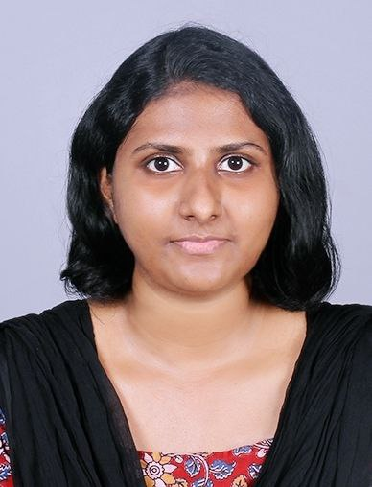
Jincy MJ Education
PH: 8075363229 * BSW From IGNOU – Pursuing
jincymj3@gmail.com * Batchelor Of Theology in 2017 from
Chaluvelil Mattathil (H) Mt.Zion Bible Seminary
Kuzhimattom PO Pathanamthitta,Kerala
Kottayam,Kerala. * Higher Secondary in 2014
Date of Birth – 07/05/1996 SKV Government Higher Secondary
Kottayam, Kerala
Objective
Seeking a position in a dynamic organization where I can launch my career and work towards building a strong skill set. A hard working individual looking for a challenging position where I can showcase my skills and contribute to the growth of the organization.
Work Experience
I have worked as a Customer Service Executive in Head office of Popular Mega Motors at Kochi since September 1st 2022 to March 31st 2023.
Skills
* Computer * Language
MS Office Malayalam and English
Place :
Date :

