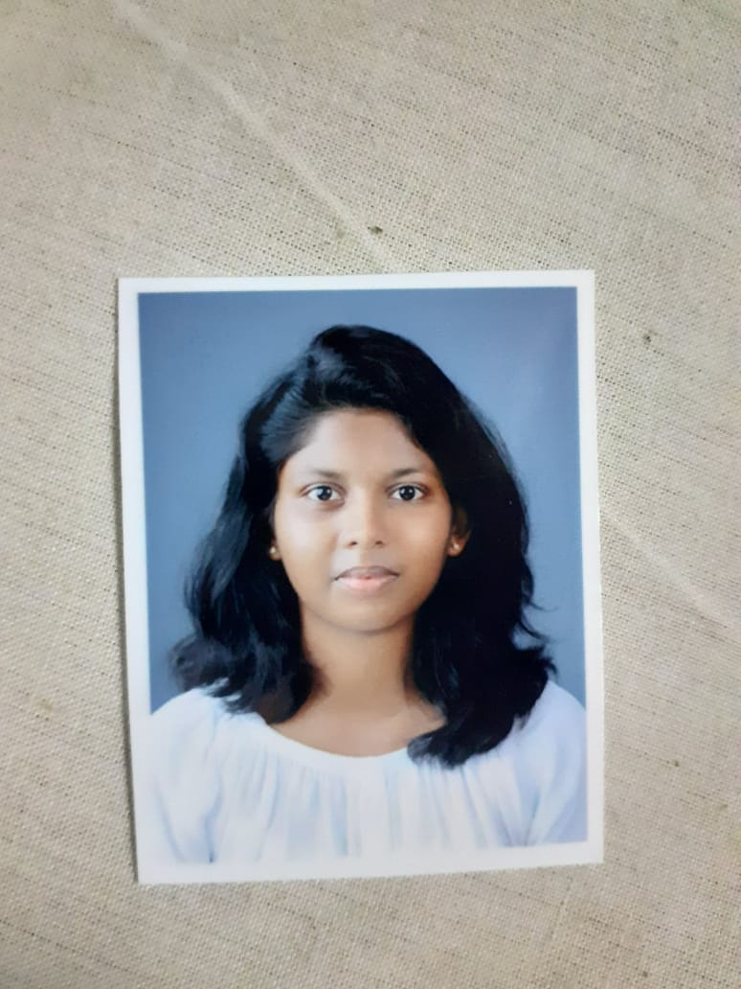

**EDUCATION**

ST. Joseph’s CGHSS Tripunithura –Higher Secondary education in March 2018. Mar Elias College Kottappady – Bachelor of Social Work in 2019-22 batch.

**PROJECTS**

2022 September – volunteer in Solace Kochi.

2021 December – 2022 January- did an internship in QSSS Kollam, CHILDLINE, CWC Kollam and JJ BOARD.

2018 July – September – volunteered as spoken English teacher in Saraswathi Vilsam School Kannankulangara.

**PROFESSIONAL QUALIFICATION**

Professional Social Worker

Diploma in Financial Accounting

Intermediate level in Microsoft office word, excel and power point.

English proficiency test band score overall 7.

Currently volunteering as psychiatric social worker in General Hospital. Ernakulam.

**PERSONAL INFORMATION**

FULL NAME: Dawn Sara George

DATE OF BIRTH: 25/06/1999

GENDER: Female

**CORE SKILLS**

Communication, problem solving, negotiation skills, adaptability, critical thinking, writing skill, project planning, data analysis, inculcating skill and administrative.

**LANGUAGES**

Malayalam and English

**INTERESTS**

Reading books, Journaling, Extensive Reading, Gardening, Travelling and listening to music.

**SUMMARY**

A social work graduate who is passionate on learning and seeking work experience to imply the skills learnt through educational knowledge and to improvise the skills into expertise goals. Young and matured individual with developed skills and personal attributes that will support the transition from education to full-time employment.

**DAWN SARA GEORGE**

**SOCIAL WORKER**

**MOBILE: 7994112334**

**EMAIL:** [**dawnsarag@gmail.com**](mailto:dawnsarag@gmail.com)

**ADDRESS: Flatn no. B5 Kailas Apartment Vadakkekotta, near Chiking, Tripunithura, Ernakulam, Kerala. 682301.**