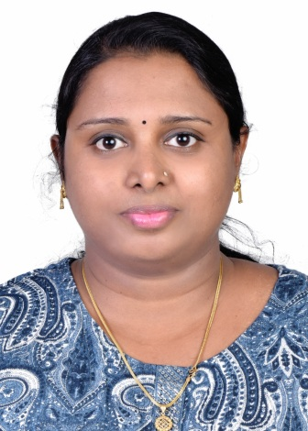  VISYA VIKRAMAN.S  Contact:+91 9526017043, +966 503567036  E-mail: vis.vik.043@gmail.com  Passport Details:  Passport No : M4584679  Date of Issue : 26-12-2014  Date of Expiry : 25-12-2024  Address:  HarimughathuVeedu,  Kalathukal, Karakulam.P.O,  Thiruvananthapuram,  Kerala – 695 564, India  Personal Profile:  Date of Birth : 19-04-1989  Gender : Female  Nationality : Indian  Marital Status: Single  Linguistic Abilities:  - English  - Malayalam  - Tamil  - Hindi  - Kannada  - Arabic  References:  - Lt.Col. (Rtd) Salimma Thomas  General Manager – Nursing  RenaiMedicity Multi super Speciality Hospital, Palarivattom,  Kochi, Kerala  Ph: +91 484 4331320  Email: hr@renaimedicty.org  - Mrs. Saly Jacob  Nursing Supervisor  Al-Qunfudah General Hospital  Al-Qunfudah  Saudi Arabia  Mob: +966 55269136  Email: saly00sony@gmail.com  - Dr. Heba Hassanien Ibrahim  Pediatric Consultant and Neonatologist  Head of the Department  Al-Qunfudha General Hospital  Mob: +966 553125893  Email: dr.hebahassaien@Yahoo.com | CURRICULUM VITAE
 | OBJECTIVE
 | To work with full dedication and knowledge to serve the organization with my fullest capability.
ACADEMIC QUALIFICATION:
- B.Sc Nursing from Mother Teresa Nursing Institute, Vivekananda Nagar, Mysore, Karnataka. (Rajeev Gandhi University), 2008-2012. Percentage : 61.80 %
- PlusTwo, (+2) from G.G.H.S.S, Cotton Hill, Trivandrum, Kerala, 2005-2007, Percentage : 72.5%
- S.S.L.C, (10th) from G.G.H.S.S, Cotton Hill , Trivandrum, Kerala, - 2005, Percentage : 73.6%
Language skill:
- Occupational English Test (OET)
W/B, S/C+, R/C+, L/C
Expiry on 10th September 2024

Technical knowledge:
- M S Office
- HTML
LICENSE:
- Kerala Nurses and Midwives council
- The Karnataka State Nursing Council
PROFESSIONAL SKILLS :
- Assisting in intubation and ventilator handling
- BLS
- ABG analysis
- ECG
- Ventilator knowledge
- Neonatal care
- Defibrillator
- Care of invasive and non invasive lines
- Medication calculation and administration
- Biomedical waste management.
- Handling in all types of medical equipments
- Handling of syringe pumps and infusion pumps

EXPERIENCE :
- Still Working at Renai Medicity Multi super Speciality Hospital, Palarivattom, Kochi, Kerala from 4th Sepctember 2023 onwards in NICU
- Worked as MOH staff nurse at AL-QUNFUDAH GENERAL HOSPITAL, SAUDI ARABIA since
- ICU - 2ndJune 2015 to 31st August 2019
- NICU - 1st Sep. 2019 to 7th March 2023

- Worked as staff nurse at TATA MAIN HOSPITAL, JHARKHAND for 2 years in Operation Theater (General surgery, Ortho, ENT).
- O.T – 15th April 2013 to 17 May 2015
PROJECTS :
- MAJOR: A Study on knowledge level of 3rd year nursing students regarding “Antenatal Exercise” in Mother Teresa Nursing Institute, Mysore, Karnataka.
- MINOR: A Study on knowledge level of 1st year nursing students regarding “Jung Food” in Mother Teresa Nursing Institute, Mysore, Karnataka
PROFESSIONAL INTEREST :
- Taking up challenging tasks and projects under pressure.
- Excellent team player as well as a good leader.
- Adaptability in any situation.

 | DECLARATION :
The above information is true to the best of my knowledge and belief. I assure that I will perform my duty and meet the organizational requirement.

Place :Thiruvanathapuram
Date : VISYA VIKRAMAN.S

