aiswarya saji
aiswaryasaji1243@gmail.com
9207923274

Objectives
Seeking a position as nurse in a reputed hospitals where I could serve to the patient and gain good skill in my profession and help the organization in building a good reputation.

Education
Done bachelor of Nursing from Sri Devaraj Urs College Of Nursing in 2022 with First Class.
Passed senior secondary from Government Higher Secondary School Namakuzhy with science-Biology subject in year 2018 with 65%.
Passed Secondary Education from Lake Mount Public School Kattikunnu in year 2016 with 62%

Experience
24 weeks of internship posting was completed from R L Jalappa Hospital And Research Center Tamaka Kolar.
Learning’s Includes
- Helping the doctors in checking the patient.
- Dressing (bed sore, surgical wounds, etc.)
- Performing admission, discharge and transfer of the patient.
- Maintaining records and reports.
- Compassion for Family and Patient, Comfortable Answering Queries and Giving Instructions To Patient And Family.
- Performing basic check-up like BP check, weight check etc.
- Attending patients need basic treatments like bandage, injections
- Daily check-up of patients.
- Responsible for daily dose and routine injection of patient.

Skills
- Polite and soft in nature.
- Loyal towards my work and duties.
- Can manage the problems easily.

Equipment Handling
- Cardiac monitor.
- Pulse oxymeter.
- ECG Machine.
- Glucometer.
- BP apparatus.
- Thermometer.
- UV / IR Light.

Areas Of Interest
- Postoperative care unit.
- Casualty.
- Medical Intensive care unit.
- Labour Room.

AWARDS AND ACHIEVEMENTS
- Participated in various cultural activities.
- Participated in Camp.

certificates courses
- Karnataka State Nursing Council.
- Provisional Degree Certificate.
- Digital Healthcare [Telemedicine].
- Yoga.
- Nursing core competencies in Non Communicable Diseases.
- Self Esteem and Personality Development.
- Act Fast And Smart- Golden Hour- First Aid.
- Crime Against Women – Challenges In Emergency Room.

hobbies
- Watching Movies.
- Listening Music.
- Reading fiction stories.
- Cooking.
- Dancing.

Extra Curricular Activities
Went to General Health Camp from the Sri Devaraj Medical College for Rural peoples.

Computer Proficiency
- MS Office.
- Internet.

Personal Details

Date of birth: 31-01-1999
Languages known: English, Malayalam,[Kannada, Tamil, [Hindi able understand]

certicates attaching
1] BSc Nursing
1ST yr

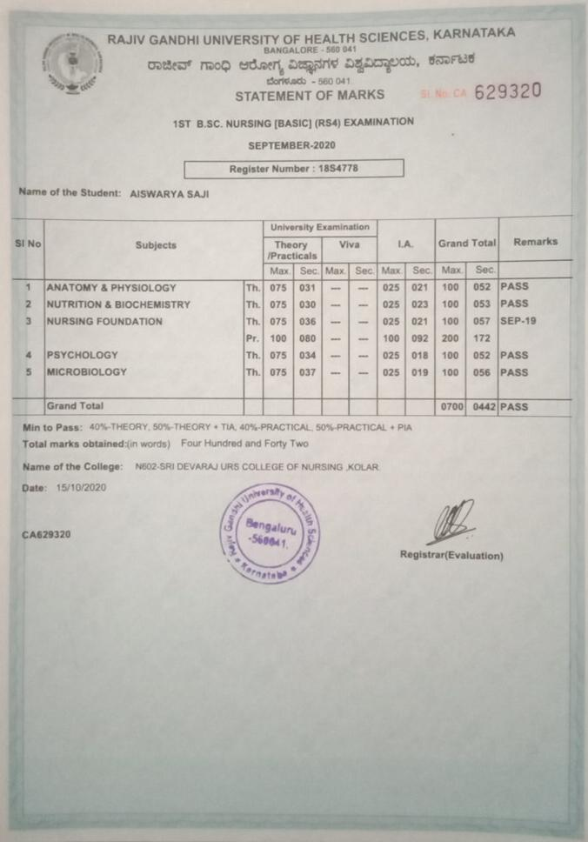
2nd yr
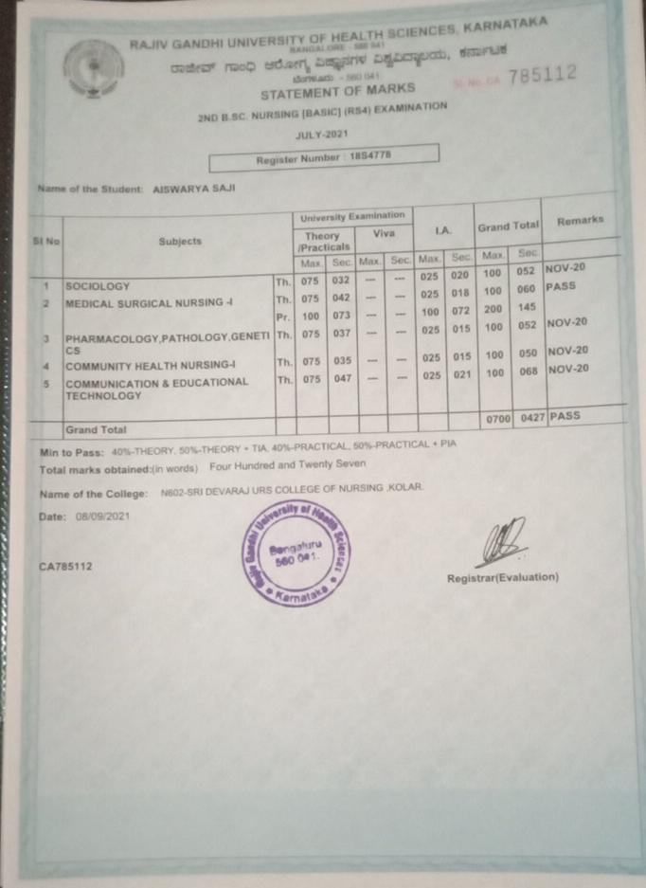
3rd yr
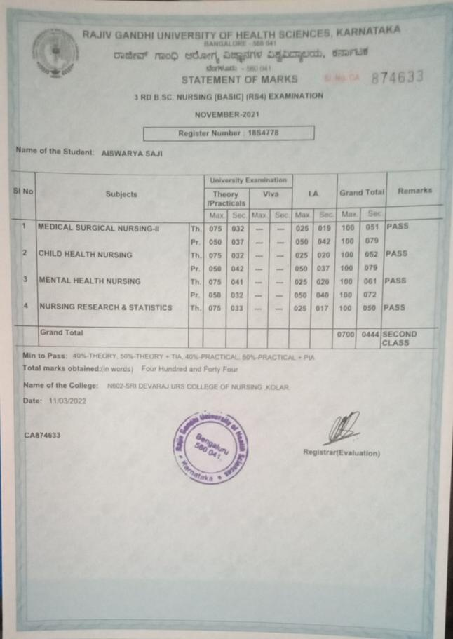

4th yr
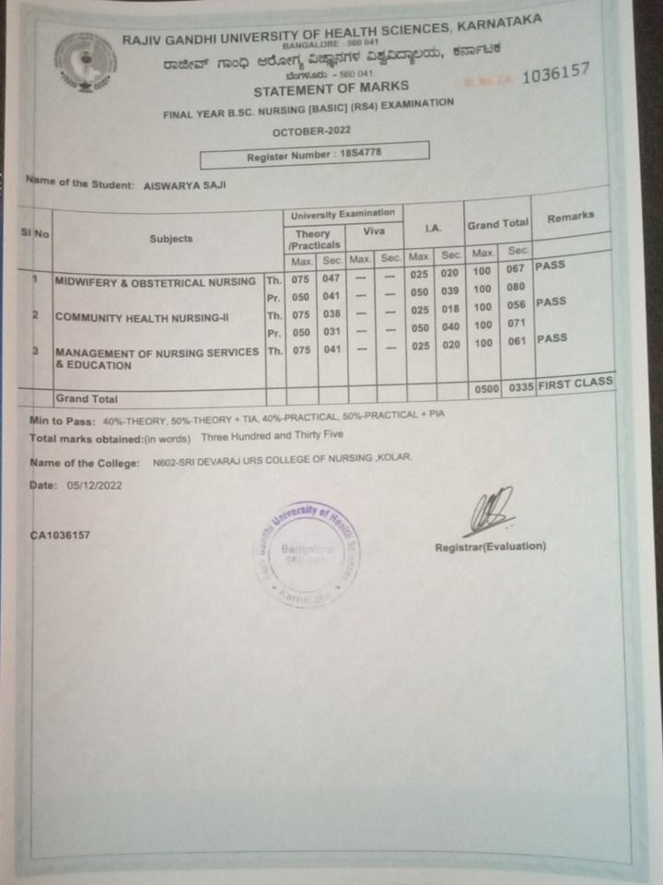

2] Senior Secondary
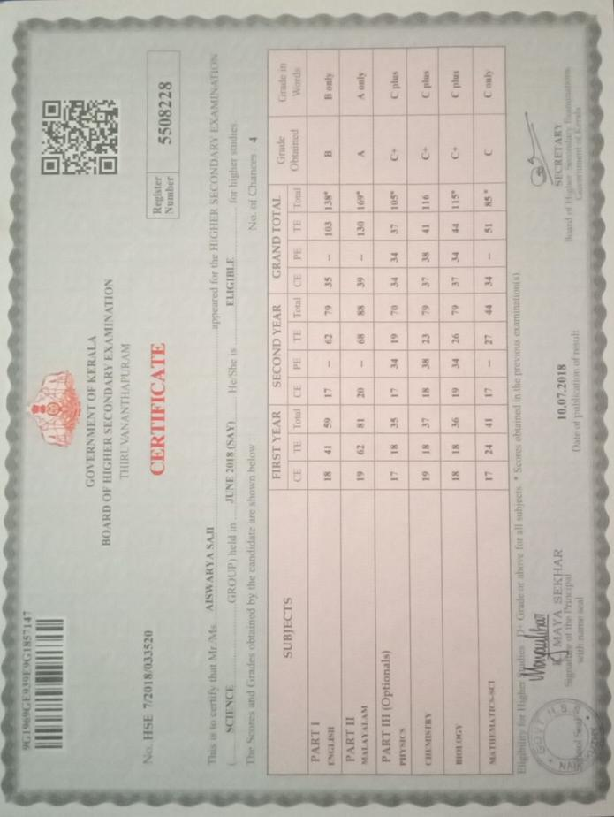

3] Secondary
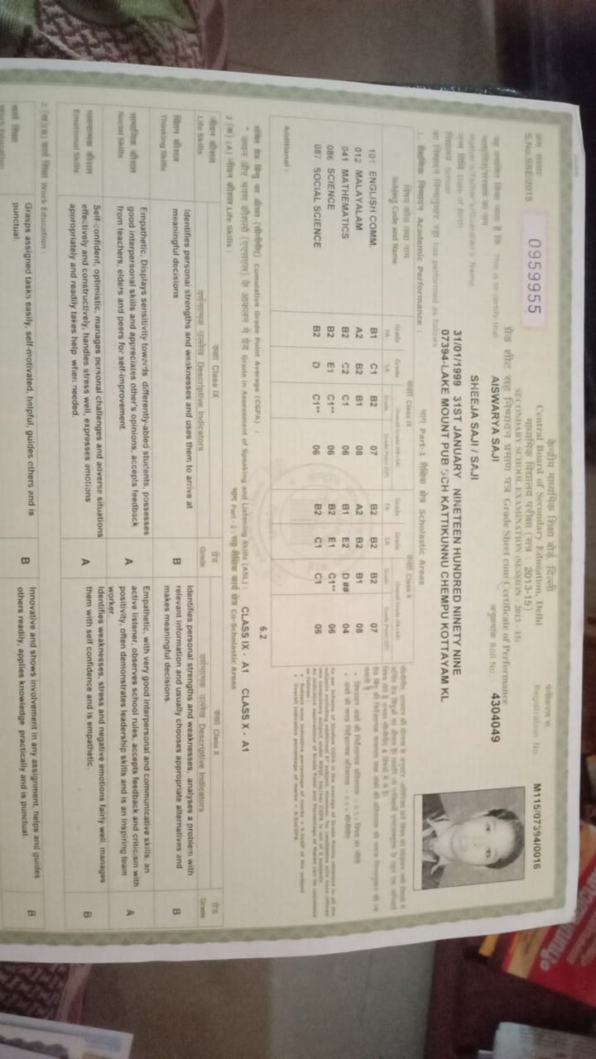
4] KNC
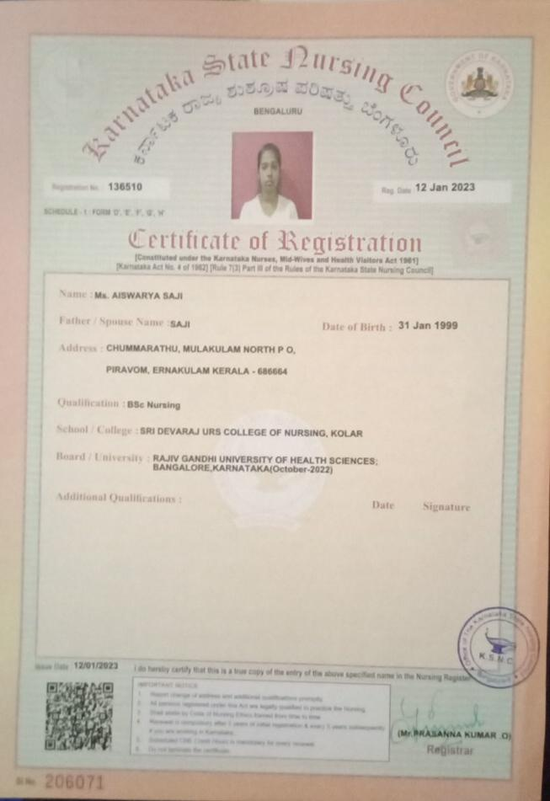

5] PDC
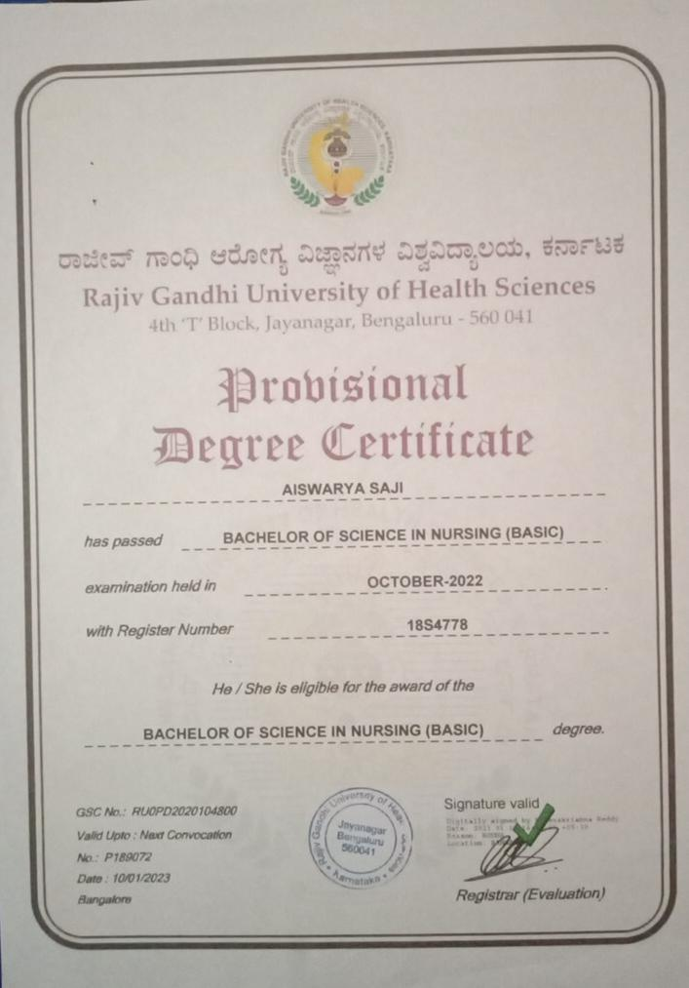

6] Digital Healthcare
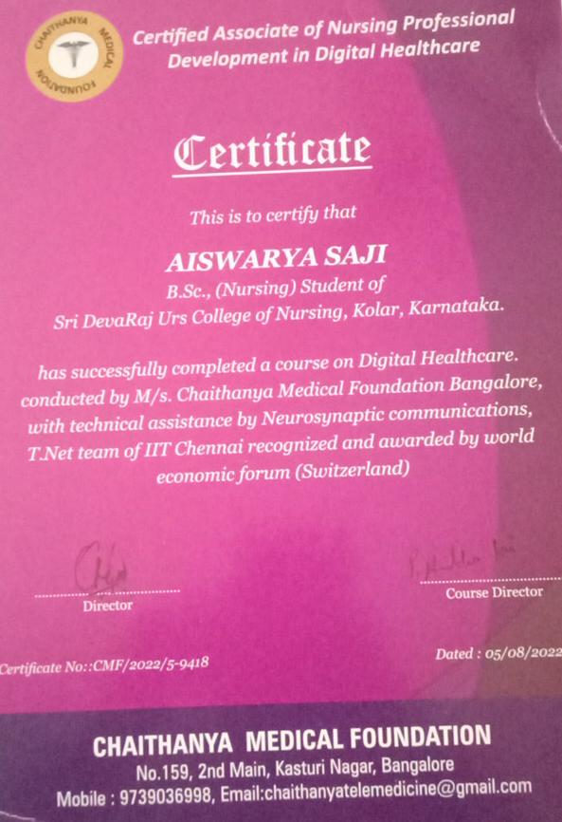
7] Act Fast And Smart Golden Hour First Aid
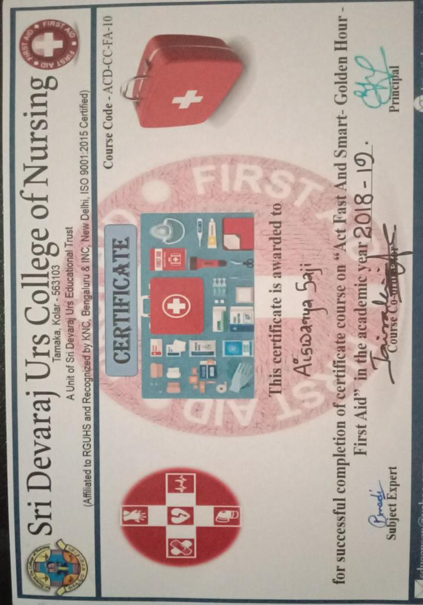

8] Self Esteem And Personality Development
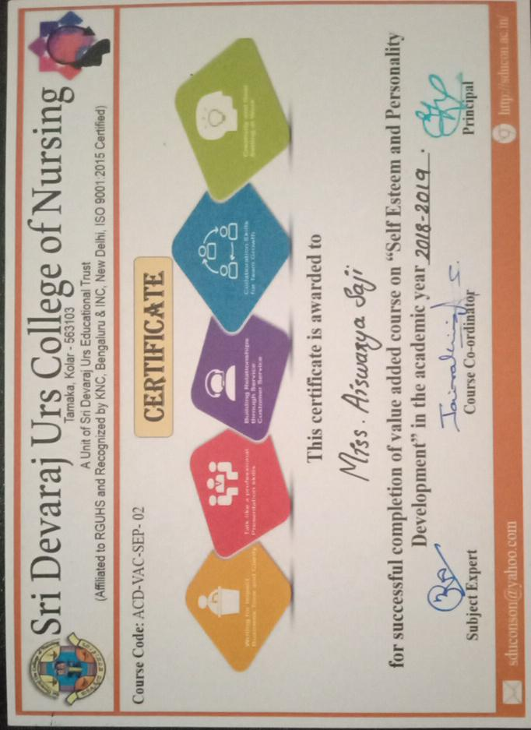

9] Nursing core cpmpetencies in Non Communicable Diseases
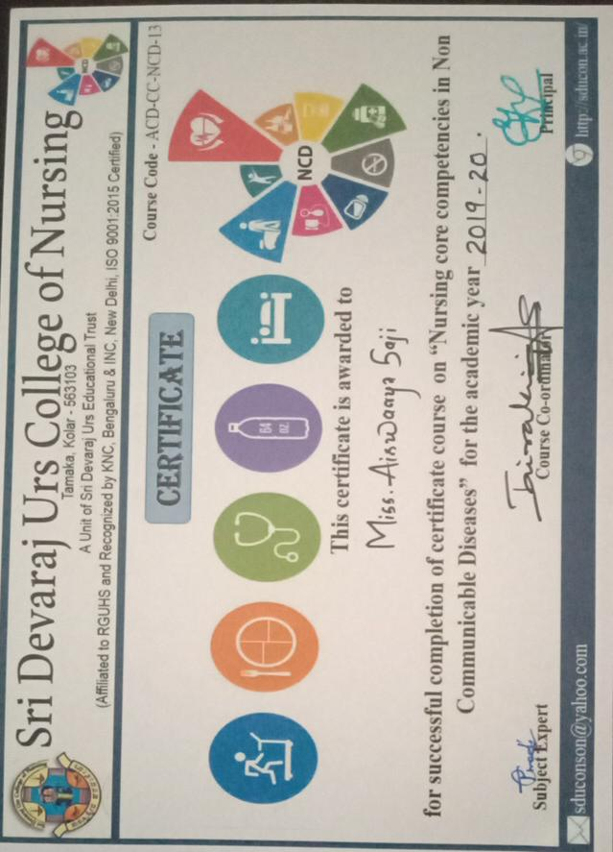
10] Yoga
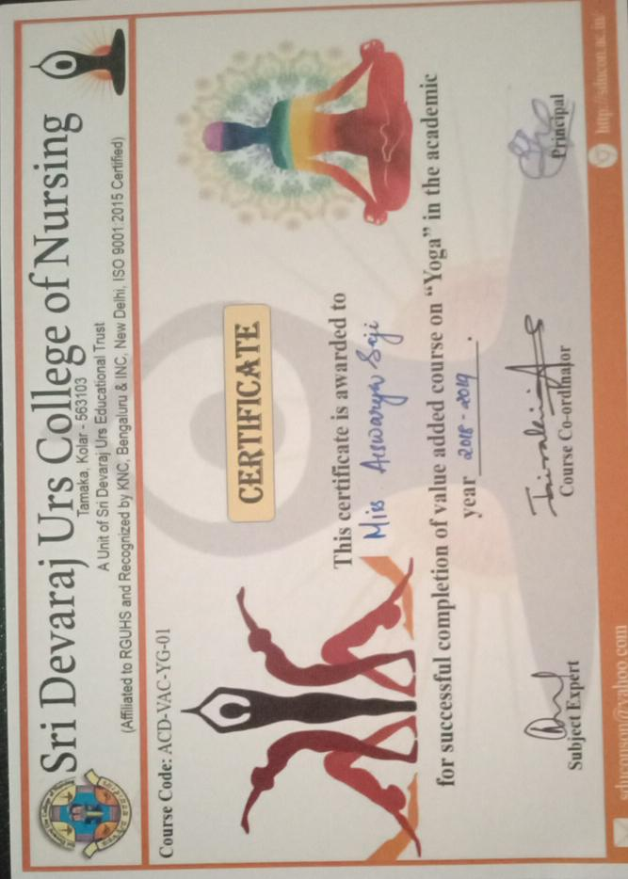

11] Crime Against Women Challenges In Emergency Room
