CURRICULAM VITAE
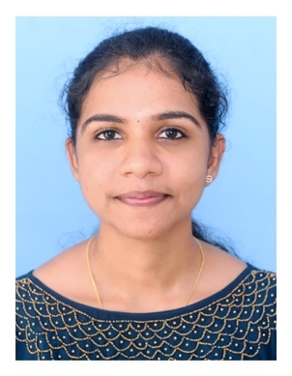
NITHYA MANOSH
Phone:+918606913245
E-mail:nithyamanosh@gmail.com

OBJECTIVE
To give the best of my capabilities and calibre in the field of my career by portraying positive attitude,commitment,and honesty in my duties and also to attain a consulting postion with the organization that will enable me both to contribute and learn.
To secure a challenging position in a reputed health care institution where there is a scope for acquiring,updating and utilizing my knowledge and skill for the development of self as well as the organization.
SKILLS
>Communicating with doctors,patients,other departments and co-workers about patient care,locating and sharing resources and organizing of patient care.
>Promoted health care for both patients and their families,dissemination of information to support groups.
>Developed knowledge,skills and expertise in nursing the critically ill.
>Expert in moving and handling of patients.
>Developed compentency through clinical placement in monitoring heath of individuals,groups and communities.
>Highly competent in comparing assessment findings with what is expected for the condition ,and include or exclude alternative diagnoses as developed through clinical rotations.
>Proven ability to comply with relevant documentation requirements,including maintenance of client records and discharge planning developed by Physicians.
EDUCATION
Qualification | UNIVERSITY/Board of passing | Percentage Obtained | Year of passing
B.SC Nursing | Kerala University of Health and Science | 1 Year -63.6%  2Year -65.3%  3Year-74%  4Year -73.6% | 2023
12th Standard | Kerala Board | 84% | 2018
10th Standard | Kerala Board | 87% | 2016

ORGANIZATIONAL EXPERIENCES
>Fresher and having clinical experience under the guidance of college professors during the course period.
TRAINING
>Patient care training during my course of studies.
EMERGENCY MANAGEMENT OF THE CRITICALLY ILL
During my course of studies
>Had training in government general &maternity hospital.
>Cardio Pulmonary Resuscitation
>Suctioning
>Intubation
>Oxygen therapy
EQUIPMENTS HANDLED
>Glucometer
>Infusion pump
>Syringe pump
>Nebulizer
>Cardiac Monitor
>Suction Appartus
>Thermometer
>Steam Inhaler
>Pulse Oxymeter
SOFTWARE SKILLS
>Proficient in Microsoft Office Suite
SERVICE EDUCATION PROGRAMME ATTENDED
- Safe Injection procedure
- IV Cannulation
- Artificial Respiration and CPR
- AIDS Programme
- Diabetic Management
- Needle prick injuries and its management

LANGUAGES KNOWN
>English
>Malayalam
>Tamil
>Hindi
PERSONAL PROFILE
Date of birth :12 August 2000
Gender :Female
Nationality :Indian
Religion :Hindu
Marital status :Single
Father`s Name :AV Manosh Kumar
Permanent Address:Akkakkattil(H) Neendoor po Kottayam Kerala,686601

(NITHYA MANOSH)

