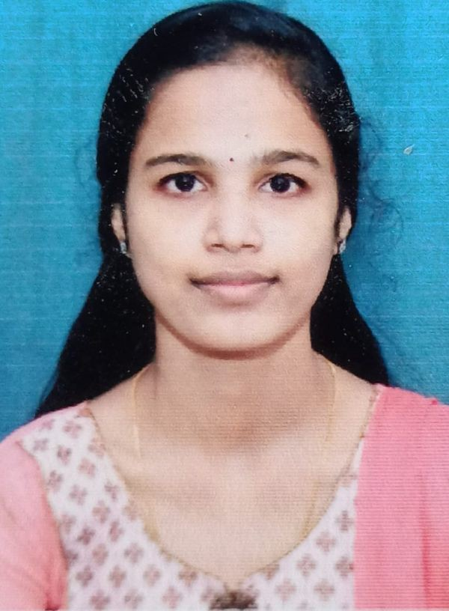
SNEHA BAIJU
Kandathil house Thirunalloor P O, Cherthala Allapuzha district, 688541 snehabaiju01@gmail.com | 8590498430
27/02/2001

OBJECTIVE
A passionate Bpharm student looking forward to work with a professional work driven environment.
Offers deep passion for medicines, good communication skills, well developed time management skills and signiﬁcant ability to work under pressure

EDUCATION

ST MARY'S GHS, CHERTHALA
10 th

ST LITTLE THERESA'S GHSS, VAIKOM
plus two

ST JOSEPH'S COLLEGE OF PHARMACY
Bpharm
PERSONAL INFORMATION

Gender: Female
Father's Name : Baiju Joseph Marital Status : Single
2016

2018

SKILLS
Customer Service Skills Clinical application Team management Patient counciling Active listening
EXPERIENCE
Completed 150 hrs of intership as per KUHS syllabus at Rajagiri Hospital, near GTN junction, chunangamvely, Aluva (15/06/2022-15/07/2022)
LANGUAGE
English Malayalam
DECLARATION
I hereby declare that the above given information is true and correct to the best of my knowledge and belief. Place : Thirunalloor

