Aleena Biju | 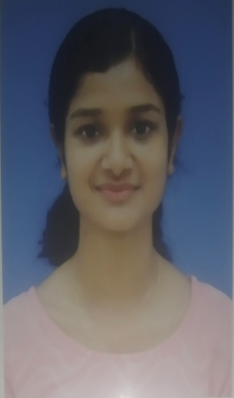
kunnappilly(house) kuttichira (po) kuttichira,680724(pin) kerala, india
9207477265 ▪ aleenabijukunnappilly@gmail.com ▪

PERSONAL DETAILS
Name : Aleena Biju
Name of father : Biju K.P
Date Of Birth : 25/09/2000
Age : 22
Religion : Christian, Orthodox
Sex : Female
Marital status : Unmarried
Nationality : Indian
Languages known : Malayalam, English, Kannada
Contact : 9207477265

OBJECTIVES

To obtain a challenging career position, this will exploit my educative and professional experience to the maximum

EXPERIENCE
▪ 30/01/2023 – 30/07/2023
Internship
In General Medicine and Surgery ward
Internship
In General ICU & SICU
Internship
In OBG & Pediatric Department
Internship
In Neurology Department
Internship
In Orthopedic Department
Internship
- Community posting
- Old age home & affiliated PHC'S
- Chetana special school, Mangalore
- Spandana Special School, Surathkal

SKILLS
- Patient Assessment
- Pain Management and
- Techniques
- Manual Therapy Techniques
- Sports Taping
- Dry Needling
- Communication skills
EDUCATION
- Bachelor of Physiotherapy
Rajiv Gandhi university of Health Sciences, Karnataka
Srinivas College of Physiotherapy, Mangalore
completed in 2023 (2018-2023)
- Higher Secondary
St. Sebastián’s HSS kuttikad
completed in 2018 (2016-2018)
- SSLC
GHSS Chaipankuzhi
completed in 2016(2015-2016)

PERSONAL PROJECT
- Project done on "Immediate Effects of IASTM on Pain and Range of Motion in Chronic Non-Specific Low Back Pain - A single-group pretest-posttest study"
- Presented a Poster on the title "Effects of Aquatic Therapy in post-stroke patients"

COURSES AND SEMINARS
- March 2020 | Chennai, India
participated in Annual Conference of The Indian Association of Physiotherapist.
- March-April 2023 | Sharp Insight
Dry Needling, Radiology, Myokinetic Therapy, Taping.
- April 2023 | Course in Manual Therapy.
- July 2023 | Srinivas University
participated in “NEUROCON 2023 NATIONAL LEVEL CONFERENCE”

CERTIFICATES
- Certificate course in Manual Therapy organized by Manual Therapy Foundation of India
- On Mechanical, Radiological, Differential diagnosis & it's Dry Needling & Myokinetic Therapy in Musculoskeletal disorder

