CURRICULUMVITTAE

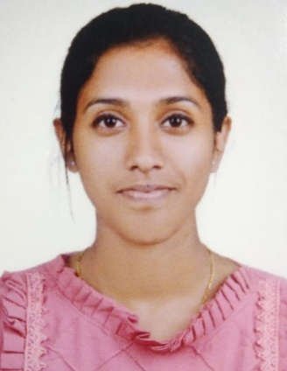

NAVYA PA
EmailID:navyapa2000@gmail.com

Phonenumber:6235523451

CAREEROBJECTIVE

Seeking a position to utilizes my skills & abilities in nursing field that offerprofessional growth while being resourceful, innovative & flexible, and secure a challengingpositionwhereIcaneffectivelycontributemyskillsasprofessional,possessingcompetentskills.

ADDRESS

COMMUNICATIONADDRESS: | PERMANENTADDRESS:
Navya parathanath  Mannamanglam (PO)Thrissur(Dist.)Kerala  PIN:680014 | Navya parathanath  Mannamanglam (po)Thrissur(Dist.)Kerala  PIN:679106

PERSONALSTRENGTH
- Teamworking and good communication skills
- Quickadaptingto anysituation
- Loyaltowardswork
- Disciplined,polite&patience
- Capableofinteractingconfidentlywithpeopleatalllevels

PERSONALINFO:
Dateofbirth : 19-12-2000
Father’sName : Aniyan thomas Sex : Female
Age : 22years
Religion&caste : Christian Nationality : Indian
Maritalstatus : Single

ACADEMICQUALIFICATIONS:

COURSE | INSTITUTION | BOARD/UNIVERSITY | YEAR OFPASSING | PERCENTAGEMARKS
Bsc NURSING | Seventh Day Adventist college of nursing, kanniampuram, Palakkad | KeralaUniversity of Health and Science | 2023 | 66.76%
HSE | Government | Board of higher | 2018 | 76%
 | highersecondary | secondary
 | school, | examination,keral
 | Anchery | a
 | thrissur,kerala
SSLC | St.Sebastian's HSS, mannamanglam thrissur  kerala | Board of publicexaminations,kerala | 2016 | 85%

LANGUAGESKILLS:

Language | Read | Write | Speak
English | ✓ | ✓ | ✓
Malayalam | ✓ | ✓ | ✓
Hindi | ✓ | ✓ | -
Tamil | - | - | ✓

DECLARATION
Iherebydeclarethat theabovementionedinformationiscorrectuptomyknowledgeandIbeartheresponsibilityforthecorrectnessoftheabove-mentionedparticulars.
Place: Mannamanglam Name:Navya PA
Date: 17.06.2023

