CURRICULUM VITAE
ANOOP UNNIKRISHNAN
Diploma IN COMPUTERIZED INSTRUMENTATION

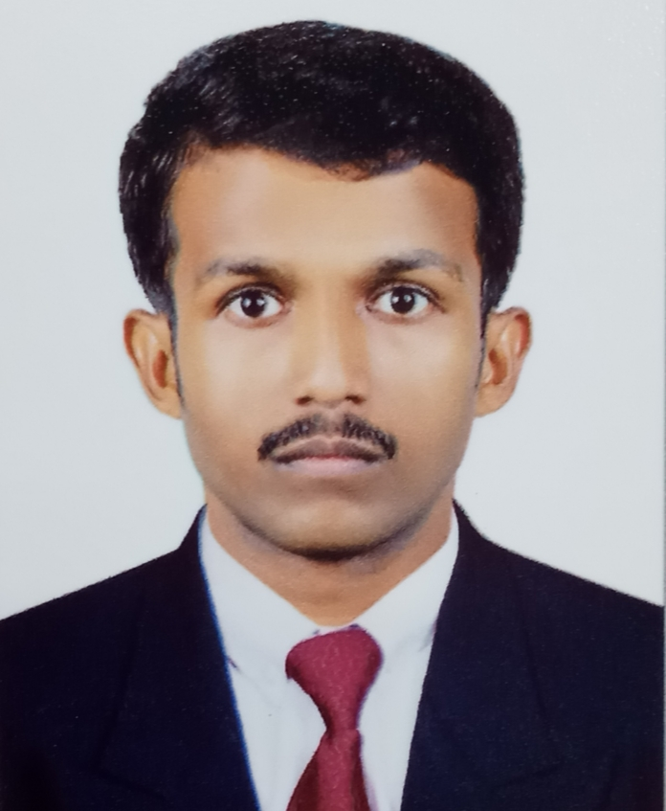

Contact Information

Kallikattil H
Valayanchirangara P.O
Perumbavoor
Ernakulam
Pin: 683 556
INDIA: 9497365957,9061692167

E-mail
anoopunnikuttan@gmail.com
Skype id :live:anoopunnikuttan

Personal Data

Father's NameK.M.Unnikrishnan
Date of Birth:16/02/1988
Sex : Male
Nationality : Indian

Marital Status: Single

Language proficiency

English
Hindi
Malayalam
Tamil

OBJECTIVE
To work in a healthy, innovative and challenging environment extracting the best out of me, which is conductive to learn and grow at professional as well as personal level thereby directing my future endeavors as an asset to the organization.

COURSE | INSTITUTION | YEaR | %
Diploma in Computerized Instrumentation | G P T C Perumbavoor | 2011 | 70
I.T.C Electronics & Communication | KGCE(Southern Engineering Institute,  Perumbavoor) | 2006 | 63
TECHNICAL QUALIFICATIONS

CURRICULUM QUALIFICATIONS

COURSE | INSTITUTION | YEAR | CLASS / %
SSLC | H.S.S.Valayanchirangara | 2004 | 45%

EXPERIENCE

*5 Year experience in Electronics Service Engineer in A&M Healthcare Company from 1-2-2008 To 31-12-2013

*Electronic production supervisor in meembit technologies From 1-2-2014 To 9 – 9 -2015
*Service Engineer in DEWTON INDUSTRIES from 7/06/2018 TO 29/06/2019
*Worked as Service Engineer ( TRC ) at Kirloskar Technologies (P) Ltd -Kerala Government Project for 10-10-2019 to 2-2-2022.
* Working as Service Engineer in Kirloskar Technologies Private Project Kerala From 03/03/2022 TO 14/12/2022
CO- CURRICULLAR ACTIVITIES

- Conducted and coordinated several programs at local and college level.
- Listening music

PERSONAL SKILLS

- Quick learner.
- Leadership quality.
- Dedicated and hardworking.
- Ability to work in any environment.
- Co-operate with people to learn more.
- Interested in learning new topics.
- Interested to work in any field

DECLARATION
I, hereby declare that the above information is true and correct to the best of
my knowledge andnothing has been concealed or distorted
Place: Ernakulam ANOOPUNNIKRISHNAN

