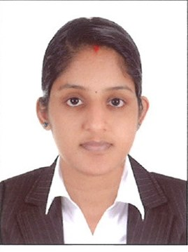
CURRICULUM VITAE

ASWANI .T.A
Mobile No: 9995467657
Email : aswaniasok90@gmail.com
Ernakulam.

PERSONAL DETAILS

- Nationality : Indian
- Date of Birth : 22/03/1990
- Religion : Hindu
- Marital Status : Married
- Sex : Female
- Languages : English, Tamil, Malayalam
- Passport number : S0873480

CAREER OBJECTIVE

A suitable position with an organization where I can utilize the best of my skills and abilities that fit my education, skills, and experience, a place where I can be encouraged and permitted to be an active participant to contribute to the development of the company

EDUCATIONAL ATTAINMENT

- School L.M.C.C. Higher Secondary Girls School in 2007
- High School Sree Narayana Higher Secondary School in 2009
- Degree B A Sociology not completed

PROFESSIONAL EXPERIENCE

SILVERLINE HOSPITAL, Kochi

- Position : Front office Executive
- Location : Kochi (India)
- Period : From September 2021 to present

RESPONSIBILITIES:
- Maintained integrity of the general ledger, including the chart of accounts
- Generated financial statements and facilitated account closing procedures each month.
- Cashier
- Billing
- Maintain administration and operation records
- Sorting daily emails based on priorities
- Updating appointments, calendars, and schedule appointments/meetings

V.G SARAF MEMORIAL HOSPITAL, Kochi

- Position. : Front Office Assistant
- Location : Kochi (India)
- Period : Oct 2013 to Mar 2018

RESPONSIBILITIES
- Maintained integrity of general ledger, including the chart of accounts
- Generated financial statements and facilitated account closing procedures each month.
- Cashier
- Billing

EXA SOLUTIONS, Kochi

- Position : Office Administrator
- Location : Kochi (India)
- Period : Nov 2012-Nov 2013

RESPONSIBILITIES

- Modified a comprehensive financial reporting package to reflect growing organizational complexity.
- Maintained integrity of the general ledger, including the chart of accounts
- Filed tax returns and prepared governmental reports in compliance with strict standards
- Analyzed monthly balance sheet accounts for corporate reporting
- Generated financial statements and facilitated account closing procedures each month
- Compiled general ledger entries on a short schedule with nearly 100% accuracy
- Use computers for various applications, such as database management or word processing.
- Answer telephones and give information to callers, take messages, or transfer calls to appropriate individuals

SKILLS

- Windows Operating System (Windows 8 and 10), Impact, Ellider
- Client Handling
- Accounting
- Office Administration

DECLARATION

I hereby certify that the above mentioned statement is correct & true to the best of my knowledge & belief.

ASWANI T.A

