CURRICULUM VITAE

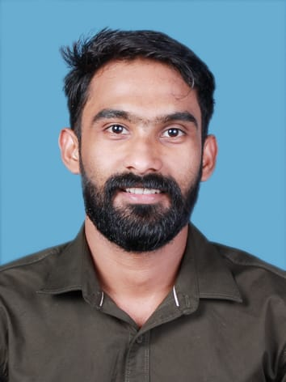
SREERAJ.S
Ottasseril (H) Thottakom PO Vaikom, Kottayam Kerala -686607
Mob :- 9995245549
Email :- sreerajsreeni4554@gmail.com

Objectives
Seeking suitable position as a professional which enable to utilize my skill and knowledge. I had gained through my education and experience and offer much versatility and commitment to excellence.

Personal Details
Father’s Name : Sreenivasan
Date of Birth : 02/03/1997
Marital Status : Single
Sex : Male
Religion : Hindu
Cast : Ezhava
Nationality : Indian
Language Known : English, Malayalam

Academic Qualification

Course | Board | Institution | Year
S S L C | Board of Public Examination | S M S N H S S  Vaikom | 2013
VHSC | Kerala Board of | S M S N VH S S | 2015

Maintenance & Repairs of Radio & Television | Vocational Higher Secondary Examination | Vaikom

TECHNICALQUALIFICATION

Course | Board | Institution
ITI Sheet Metal Worker | NCVT | Govt. ITI Ettumanoor

Work Experience
- Two Years experience in Craft man & Welder, Kondody Auto craft (India) Private Limited, Kottayam
- Two years experience in operator and helper,green method engineering (India)
- Two years experience in plant operator (w.t.p,ro plant,e.t.p,s.t.p) and plumbing ,smita memorial hospital and research centre,Thodupuzha (India)
- PERSONAL SKILL
- Self Confidence
- Communication Skills
- Flexible
- Time Management

Declaration
I hereby declare that all above mentioned are true and correct to the best of my knowledge and belief.

Place:- Thalayazham
Date:- SREERAJS

