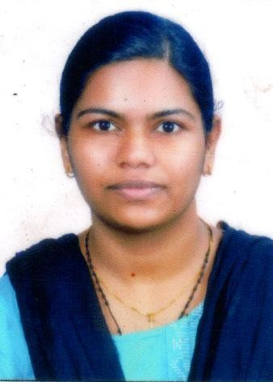
Curriculum Vitae

Juby Jose Maniangattu House Manalumkal P.O. Poovathilappu Kottayam District
Kerala, India, Pin : 686 503 Email : jubyj68@gmail.com
Mobile : +91 9847728755, 7012789583

Career Record

MGM Hospital, Chelad, Kothamangalam (2022-August 8-Current)
A Private hospital with 100 beds backed with vision to offer the best patient care and equipped with technologically advanced heath care facilities. It includes 24 hours accident and emergency care. Medical and surgical ward, Pediatric ward and Dialysis and physiotherapy department.

Staff Nurse –Medical Surgical ward
Key responsibilities are
- Initial patient assessment which includes history collection, physical exanimation and monitoring vital signs.
- Assess, diagnose, plan, implements and evaluate nursing care along with preparing patient for various invasive procedures.
- Assisting Doctors with various invasive and non-invasive procedures and monitor, record and report symptoms or changes in patient condition.
- Performing various procedures such as ECG, Urinary Catheterization, Nasogastric Tube insertion, Swab collections, wound care, Cardio Pulmonary Resuscitation.

- Safe administration of medications,. IV fluids, blood and blood products as per doctors' order and the guidelines. .
- Educate the patient and family regarding patient rights, infection prevention and discharge planning,
- Collecting blood samples and other specimens for investigations.
- Attend in-service education and trainings to enhance knowledge.

Achievements
- Got appreciation from patient and by stander.

Government Medical College, Kollam, Kerala, India (2019-April 16 -2020- April-15)
Government Medical college hospital with a capacity of 500 beds consists of departments including 24 hours Accidents & Emergency service. Medical ward, Surgical ward, Gynecology and Obstetrics ward, Labour room, NICU, Pediatric Ward and operation theatre with Laboratory as well as other diagnostic facilities. Hospital was initially established by employees’ state insurance corporation.

Staff Nurse - Medical ward
Key responsibilities are:
- Initial patient assessment which includes history collection, physical examination and monitoring vital signs.
- Keep good professional relationship with staff members.
- Making discharge file and sending for billing
- Collection, transportation of specimens and report collection.
- Be an active participant of ward meetings to improve the professional skill knowledge.
- Monitor, record and report symptoms or changes in patient condition.
- Safe administration of medications, IV fluids, blood and blood products as per doctors' order and the guidelines.

Achievements
- Community health services were conducted on behalf of the hospital
- Got appreciation from patient bystander and incharge.

Seven hills hospital, Mumbai, India (2016 June 29 – 2017 July 1)
Seven hills hospital, Mumbai is a super speciality hospital with 2000 beds and was established in 1986. This hospital is NABH, NABL and JCI accredited. And has been ranked in the 7th best hospital in Mumbai by week magazine. This hospital has performed over 2500 cardiac surgeries, 2700 angiographies and 1550 angioplasties. Seven hills hospital has 36 centers of excellence which includes cardiac, Orthopeadic, Oncology, Neurology, Cosmetics, bone and joint care and cancer care.

Staff Nurse -Medical- Surgical ward
Key responsibilities are:
- Assist the doctors for conducting rounds and maintain a rounds book for reminding important orders including verbal order.
- Patient preparation both physically and mentally along with consent form lor surgical procedures.
- Admission, Transfer and Discharge of patients.
- Provide medications and IVF therapy by following the rights of drug administration. Provide adequate nutrition by tube feeding if the patient is not able to have the food by themselves.
- Give sponge bath for bed ridden patients and proper position change to avoid pressure sore.
- Teach patient about the important of medication compliance.
- Keep good professional relationship with staff members.

Achievements
- Got appreciation from patient and by stander.
- Attended 87 hours of training.

Educational Qualifications

Bachelor of Science in Nursing from Mar Sleeva College of Nursing (2011-2015)- Kerala University of Health Science, Thrissur, Kerala, India.

Training Courses
- Basics of oncology nursing workshop – August 2018
- Cardiac thoracic surgery updates- November 2017
- Statistical skills –an Essential step towards excellence in Nursing research- March 2016

Personal

Date of Birth : 12 August 1993
Marital Status : Married
Interests : Cooking, Listen to Music, Reading
References : will be provided upon request

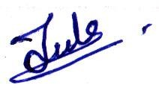
Date : 09/09/2022 JUBY JOSE

