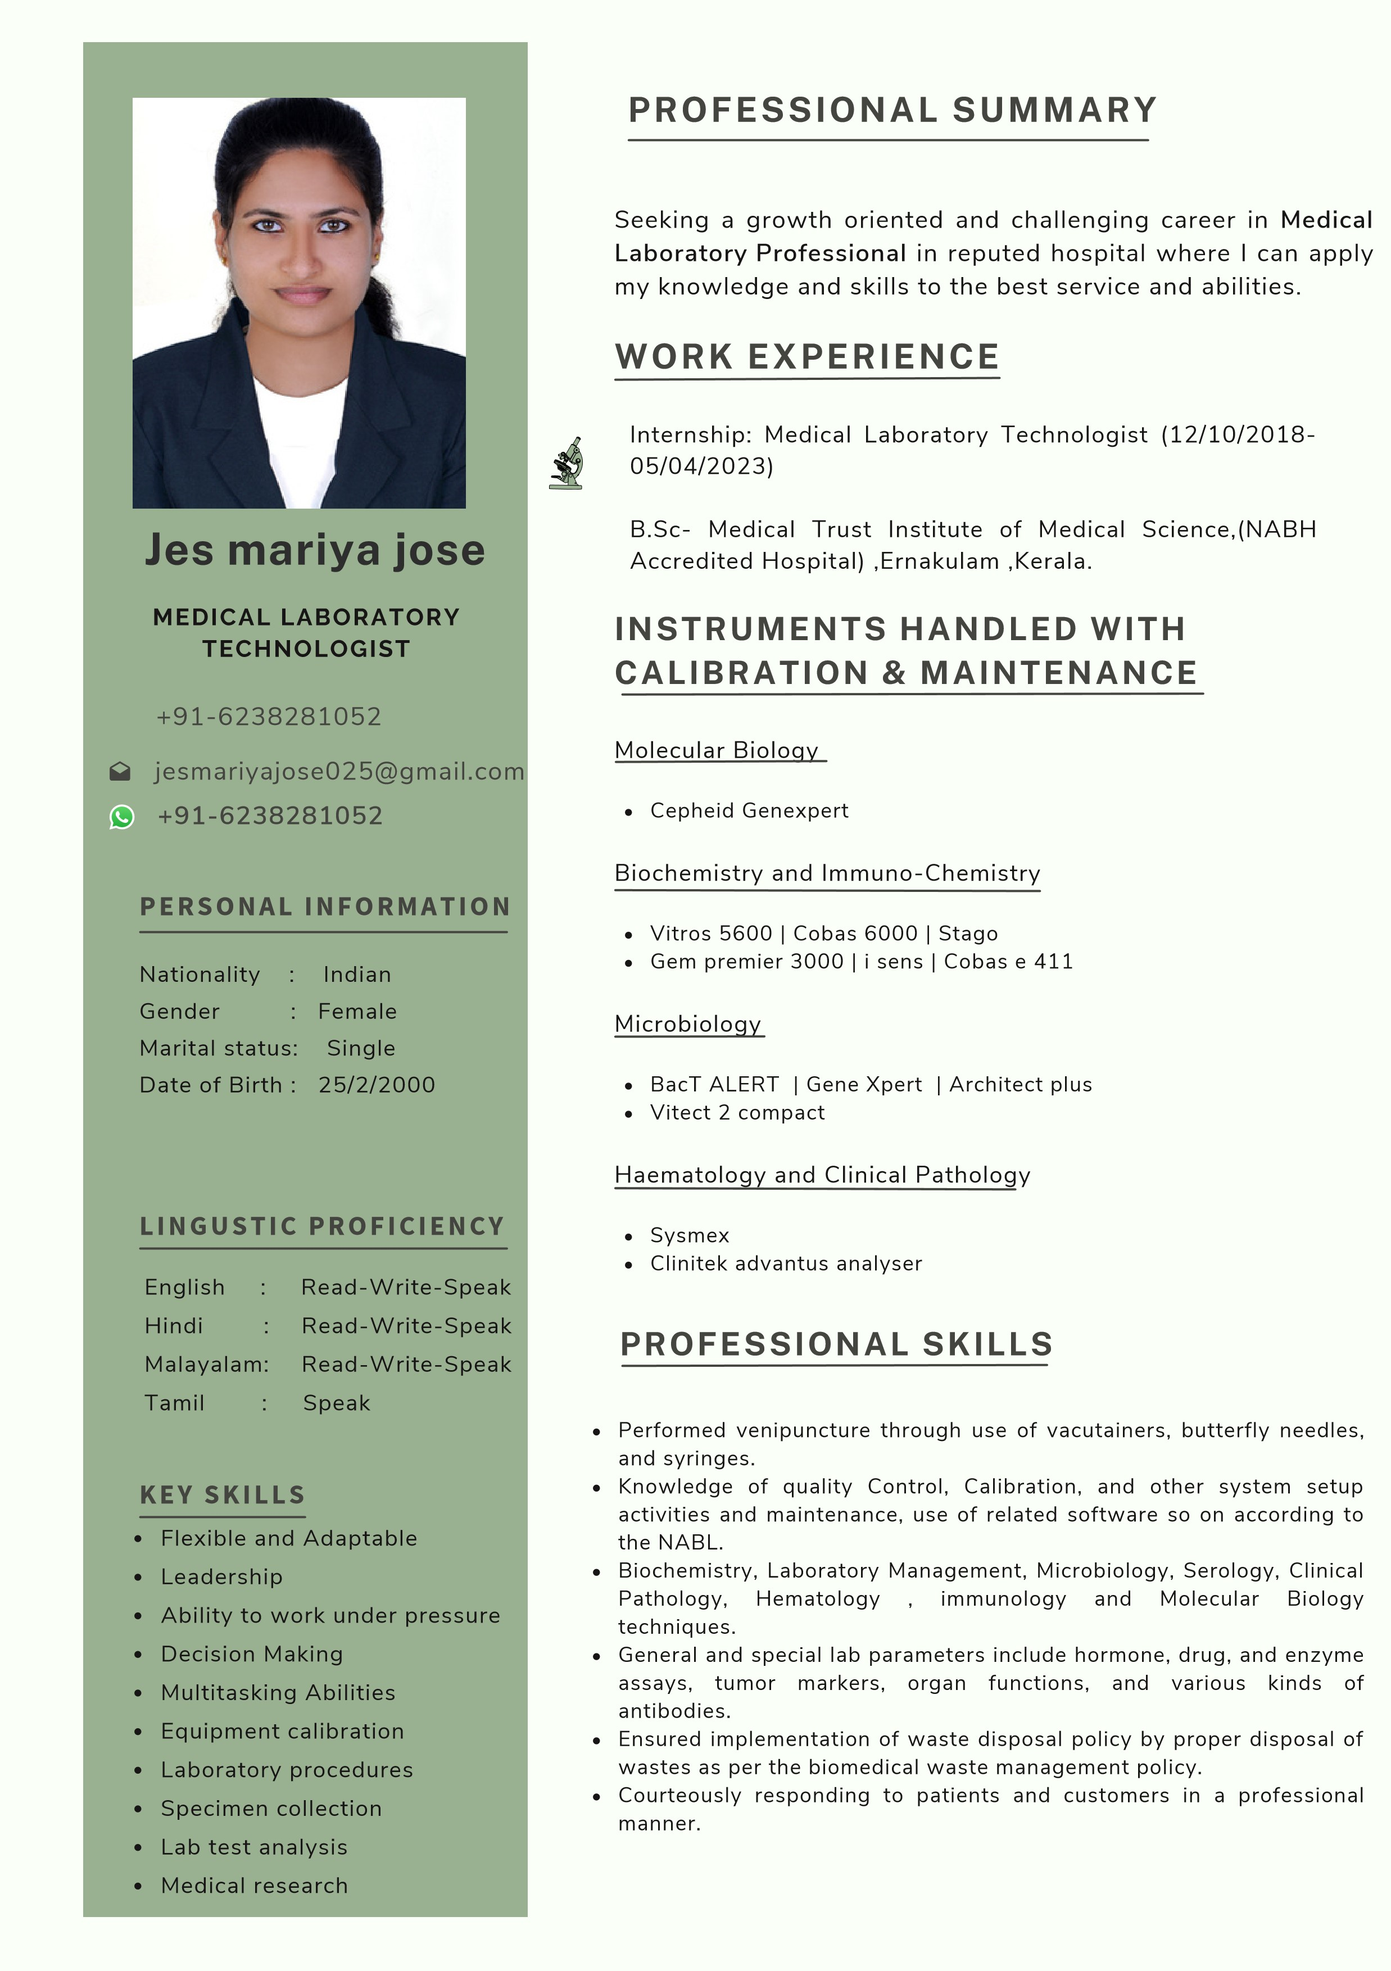
DUTIES AND RESPONSIBILITIES
- Perform laboratory testing and log testing results appropriately, according to established lab protocol.
- Make decisions on specimen validity within 20 minutes of receiving each specimen.
- Troubleshoot, diagnose and repair any issues with the equipment used in the laboratory.
- Present clients with recollection protocols in the event that a sample is rejected.
- Internship: Medical Laboratory Technologist
(12/10/2018- 05/04/2023). Medical Trust Institute of
Medical Science(NABH Accredited Hospital) , Ernakulam, Kerala
EDUCATION HISTORY

B.Sc in Medical Laboratory
PROJECT

Correlation between liver enzymes and CRP in hypokalemic patients.

REFERENCE

Mr.Romy
Head Of Department
+91 94956 77269
DECLARATION

I hereby declare that the above written particulars are true and correct to the best of my knowledge and belief.
Jes Mariya jose
Technology
Medical Trust Institute of Medical Sciences  Higher Secondary  Board of Vocational Secondary  Examination  Secondary | 2018-2023 KERALA  2016-2018  KERALA

Board of Public Examination | 2015-2016  KERALA
WORKSHOP ATTENDED

Attended “2” CME related to Quality and other advanced technology in clinical laboratory.
Attended as a Delicate in the CME “SILEX 2019, in updated on Revised National Tuberculosis Control, Pre-transplantation Immunology, Stay safe-infection control held at MIMS College of Allied Health Sciences, Calicut on 12th December -2017.
Attended Training for Emerging Technologies in POST
COVID Scenario on 28-05-2022 at IMA Hall, Ernakulam.

