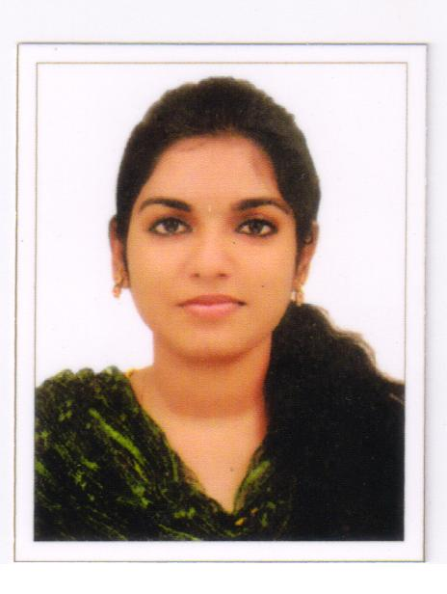
RESUME

LIA ALIAS A
PARAPURATHU HOUSE
CHERANELLOOR P.O
ERNAKULAM- 682027
Mob: 9072448892
Email id: liyaalias674@gmail.com

Career Objective:

To be a successful professional in the areas wherever am appointed in the organization in any way of contributing ideas and innovations for the overall development of the organization and the industry.

Key Skills:

Sincere towards work, honest in nature, speed and accuracy in work, keeping punctuality.

Educational Qualifications:

- Diploma in Medical Records Technology
- Plus Two from State Board
- S.S.L.C from ICSE Board

Professional Experiences:

- 6 Months Training experience in Lourdes Hospital Ernakulam.
- 1 Year experience in Sunrise Hospital Kakkanad.

COURSE | INSTITUTION | UNIVERSITY | YEAR OF PASSING
DMRT | Lourdes college of  paramedical science.  Cochin-12 | Christian Medical  Association of  India (CMAI) | 2016
Plus Two | LMCC HSS  Pachalam | Higher Secondary  Board | 2014
S S L C | Rani Matha Public  School Ernakulam | ICSE Board | 2012

DETAILS OF WORK EXECUTED:

- Maintain medical record in standardized and professional manner in order to protect patient confidentiality, assembling the records, coding then as per international standards, timely retrieval of file and making available to the concerned provide quality patient care.
- Deficiency checking.
- Gather information and provide the stage agencies about the details of Birth, Death and communicable disease.
- Organize, classify, and comply administrative and health statistics.
- Release of information.
- Sorting and scanning.
- Death auditing and communicable disease online sending.
- Dispatch of file.
- Birth death and communicable disease online sending.
- Filing.

Personal Profile:

 | Name | : | LIA ALIAS A
 | Date of Birth | : | 10/09/1995
 | Husband's Name | : | Roshin George A J
 | Sex | : | Female
 | Linguistic Proficiency  Marital status  Nationality | :  :  : | English, Malayalam  Married  Indian
CONCLUSION:

I believe in hard work sincerity and dedication. I possess the willing ability to learn and believe in being a lifelong learner. I solemnly declare that the details furnished above are true to the best of my knowledge and belief.

Place: COCHIN

Date:
LIA ALIAS A

