CURRICULUM VITAE
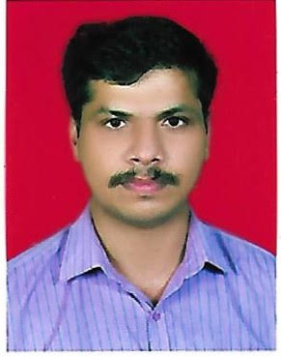

Mr. VIJIMON. K

Mob: 0091- 90484638
vijimonk@gmail.com
KOIPPURATH PADINJATTATHIL
KADAVOOR, PERINAD, KOLLAM

Professional Summary:-

- 17 Years distinguished service in the INDIAN ARMY in the field of Safety, Security, Training and operational Role.

Professional Experience - Indian Defense (ARMY 2001-2018)

- Training for Fire fighting and rescue from
- Various Diploma Courses from Army Training institutes, India.
- Served in Anti terrorism and Counter insurgency operations.
- Adventure Sports Trainer (Rock Craft, Ice Craft, Trekking, Cycling, Obstacles vault).
- IT Department Confidential Documents handling & effective record maintenance.
- Administration, Men Management, Store Management, Material Management and Efficient Supervisor Quality.
- Experience in Fire Fighting Equipments, Fire Alarm Systems and Electronics Security Gadgets.
- Qualified Army First Grade Map Reading and Global Positioning Recovery System.
- Clerical duties and Executive Assistant.

Educational Qualification:-

- Service Graduation (Defense Service) from Army, Madras Regimental Centre & College, Wellington.
- Associate Degree in Arts from Indira Gandhi National Open University.
- Secondary School Leaving Certificate, Kerala.
- Certificate in Basic Course in Tactics, Security and Vigilance from PMKV Yojana.
- Diploma in Security and Vigilance from PMKV Yojana.

Technical Profile
- Expertise in handling Semi Auto and Automatic weapons, Rocket Launchers, Grenades and explosives.
- Administrative Management Programme, Bangalore.
- Security Officer /Supervisor Course- National Skill Qualifications Frame work Level – 5 from Ministry of Skill Development & Entrepreneurship.
- IT FC computer Educations.

Linguistic Proficiency

Verbal : English, Hindi, Tamil, Malayalam.
Written : English, Hindi, Malayalam.

Computer Skills
  - MS Office Packages

Driving License Holding

Indian valid Driving Licence - All motorcycles even with gear
Light motor vehicles

Personal Profile:-

Gender Male
Date of Birth 31 Dec 1982
Nationality Indian
Religion Hindu
Marital Status Married
DECLARATION

I certify that the above information is true and correct to the best of my knowledge and belief.

Place : Kollam
Date : 12 DEC 2022 VIJI MON K

