BIO-DATA
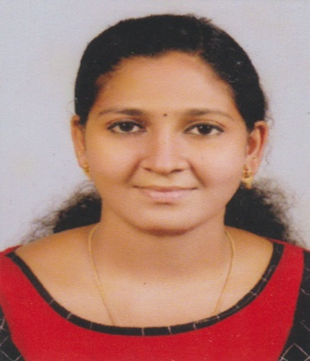
VEENA M. P
MANAVELITHARA (H)
EDAVATTOM P.O
THALAYOLAPARAMBU
KOTTAYAM DISTRICT
KERALA STATE-686605
INDIA
MOB: 9544529205
9447100918
Email Id : veena6704@gmail.com

CAREER OBJECTIVE

Work for an organization which provides us the opportunity to improve my skills and knowledge to growth along with the organization.

PERSONAL INFORMATION

Date of Birth : 23/04/1999
Father’s Name : Purushothaman T G
Gender : Female
Marital Status : Single
Nationality : Indian
Languages Known : English, Malayalam

EDUCATIONAL QUALIFICATION:

- DIPLOMA IN HOSPITAL ADMINISTRATION (June 2022) with (73%)
From Viswavidyapeedhom Educational Institution, Ernakulam, Kerala

- BSC. ZOOLOGY ( June 2020) with (62%) from (Devamatha College, Kuravilangadu) M G University Kottayam, Kerala.

- VOCATIONAL HIGHER SECONDARY (March 2016) with (75%) From (GVHSS Vaikom West) Vocational Higher Secondary Examination Board Kerala

- SSLC (March 2014) with (77%) From (A.J.J.M. G.G.H.S.S Thalayolaparambu) Public Examination Board Kerala
ADDITIONAL QUALIFICATION:

- DOMESTIC DATA ENTRY OPERATOR (2021)

WORK EXPERIENCE

Two month work experience as office assistant at krishna hospital

SKILLS

- Good Communication
- Leadership skills
- Team management
- Quick Learner

DECLARATION

I hereby declare that all the above given in formation are true in the best of my knowledge and belief.
.
Place : Edavattom VEENA M.P
Date :

