RESUME

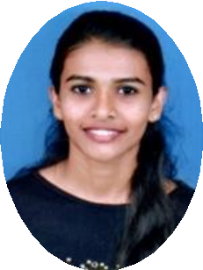
Personal Data
Name: NIMA MARIA

DOB: 01/05/2001
Address: Thyparambil house , meckenzie garden pattalam , Fort kochi
Ernakulum ,Kerala , India
Phone No.: 6363496402
E-mail ID: nimamaria01@gmail.com
Languages: English , Tamil, Kannada, Malayalam ,Hindi

Skills
Easy going, Hardworking, Flexible, Multilingual with Good Communication skills
Computer Skills: MS Office

Education
S.  No | Name of the Institution | Year of Completion | Board/ University | Marks Obtained | %
1. | Fatima girls high school Fort kochi | 2016 | State |  | 94
2. | Santa Cruz higher secondary school | 2018 | State | 864 | 72
3. | T. John College of Nursing | 2019 | RGUHS | 452/700 | 64.5

2

 |  | 2020 |  | 468/700 | 67.4
 |  | 2021 |  | 492/700 | 70.2

Awards & Achievements
- Completed research project - “A study to assess the knowledge regarding cervical cancer and it’s preventive measures among college girls of a selected college at
Bangalore with a view to develop an E- information booklet “

