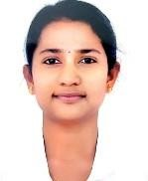
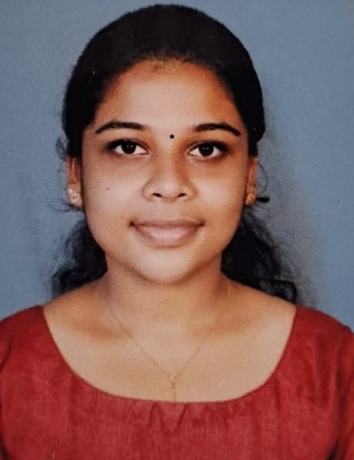
Mariya Joseph
mariyajoseph.131@gmail.com 8157018511

CAREER OBJECTIVE
To work with best of my abilities and skills in order to benefit my organization also to be better other in this competitive Time an influential position in the organization.

SKILLS
Comprehensive problem solving skills
Positive attitude
Organizing and managing capabilities
Communication skills

EDUCATION

 | Degree/Course | Institute/  College |  | University/ Board | Percentage/  CGPA | Year of Passing
 | Bsc Nursing | Global college of Nursing |  | RGUHS | 1st year=62 , 2 nd year =68 , 3 rd  year=70 , final year =77 % | 2022
 | Plus two |  |  | Board of Higher secondary  examination,  Kerala | 77 % | 2018
 | SSLC |  |  | Board of public examination,  Kerala | 88 % | 2016
 |  |  | PERSONAL DETAILS
Address |  |  | Nakathinkal (H), Kallar p o, Mundiyeruma, Kerala, 685552
Date of Birth |  |  | 13-01-2000
Gender |  |  | Female
Nationality |  |  | Indian
Marital Status |  |  | Single
Languages Known |  |  | English, Malayalam, kannada
 |  |  | DECLARATION
I hereby declare that all the details furnished here are true to the best of my knowledge and belief.

Mariya Joseph

