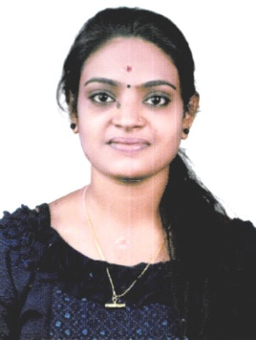
CURRICULAM VITAE
SNEHA SANTHOSH
D/o Santhosh Kumar
At: Alappuzha
Po:Kavalam
Mob: 7593953071
E-mail: snehasanthosh71@gmail.com

CAREER OBJECTIVE :
I am an enthusiastic and self-learning interested in enchanting my knowledge by working beyond my capabilities in a challenging organization, with utilizes my energy and knowledge to the fullest to meet its vision.
I can work comfortably and efficiently in team and in any environment. My goal is to learn more and provide best through best possible means. Timely submitting the given work is always one of my priorities. Seeking to work in a dynamic & challenging Environment. Optimal utilization of my skills professional growth & self fulfilment with the job.
Educational Qualification :

SI. No. | Name of the Examination | University | Institute | Year of Passing | Marks in Percentage
1 | S.S.L.C | Kerala  Secondary Education Examination Board | NSS HSS Kavalam | March  2016 | 81%
2. | Plus two | Board of Higher Secondary | NSS HSS Kavalam | 2016-2018 | 69%
3. | Diploma in Dialysis Technology | Paramedical Board Gvt of Karnataka | Mangala College Of paramedical Science, Manglore. | 2018-2021 | 87%

EXPERINCE :
- 3 Months Trainee Thanal Rehabilitation Centre, Vadakara.
- 1 and a half years working Experience and presently continuing in INF Thanal Dialysis Centre, Bhatkal, Karnataka.
- I can handle dialysis Machine namely Nipro Surdial 55. Nipro diamodel 55 plus, FreseniusModel 4008S.

TRAITS:
- Good interaction & negotiations
- Commotion & Skills
- Convincing & counseling ability
- Good listener
- Quick learning
- Patient Care
- Communication

PERSONAL INFORMATION :
Name : Sneha Santhosh
Father Name : Santhosh Kumar M
Mother Name : Sonikutty R
Date of Birth : 22-02-2001
Gender : Female
Marital Status : Single
Nationality : Indian
Religion : Hindu
Languages known : Malyalm, English
Hobbies : Music, Reading Etc…

DECLARATION :

I hereby declare that the above – mentioned information is correct up to the best of my knowledge and bear the responsibility for the correctness of the above mentioned particulars.

Name
Date :
Place : Kavalam (SNEHA SANTOSH)

