BIO-DATA

NIMMY JOY

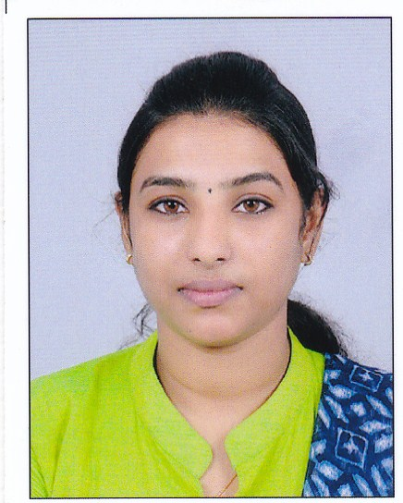

Chirappattu House

Kureekkad po

Thiruvamkulam pin: 682305

Ernakulum, Kerala, India.

Mobile: 9072120645

E-mail: nimzjoy@gmail.com

CAREER OBJECTIVE

With the organization and associate myself and achieve goals of the company in effective way. To work in environment that provides me competitive edge to sharpen my skills.

WORK EXPERIENCE

Two years working at National Institute of Open Schooling as an Executive Assistant from December 2017 to 2019

EDUCATIONAL QUALIFICATION

CAREER OBJECTIVE

Course | Discipline / Specialization | School/College | Board/University | Year of Passing | % of MARK
M.Com | Finance | St: Thomas Arts and Science College Puthencruz | Mahatma Gandhi University | 2017 | 79 %
B.Com | Computer Application | Nirmala Arts and science college Mulamthuruthy | Mahatma Gandhi University | 2014 | 80%
Plus Two | Commerce | St.Ignatious  Kanjiramattom | State Board | 2011 | 79%
S.S.L.C. | S.S.L.C. | St.Joseph CGHSS  Thripunithara | State Board | 2009 | 73%

ACHEIVEMENTS

PERSONAL STRENGTHS
- Open mentality
- Friendly mind
- Self motivating and Hardworking
- Leadership skill

PERSONAL INFORMATION
- Father's Name : Joy C V
- Gender : Female
- Date of Birth : 09/09/1993
- Nationality : Indian
- Marital Status : married
- Religion : Christian
- Languages : English, Malayalam, Hindi

ADDITIONAL QUALIFICATION
- Diploma in Computerised Financial Accounting

REFERENCE

DECLARATION

I do hereby declare that all the information is true and correct to the best of my knowledge and belief.

PLACE: Thiruvamkulam NIMMY JOY

DATE :

