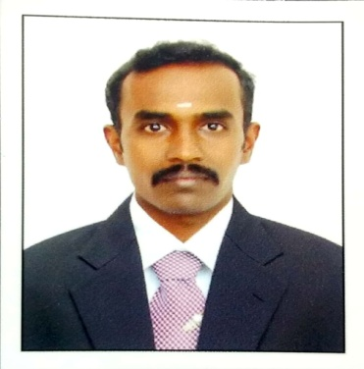
CURRICULUM VITAE

- ACHUTHABALAN ARUMAITHANGAM

D.Perfusiontechnology, B. ScphysicianAssistant
Mobile: +2348153280388
+919788128820
-email:achuthabalana@yahoo.co.in

CAREER OBJECTIVE:

Seeking a challenging position as a cardiac perfusionist, I have completed 3 years of Bsc .physician assistant and 1 and ½ years of diploma in perfusion technology from madras medical college and hospital chennai which is 3000 bedded multi speciality hospital and one of the leading cardiac centre in india, which has given me an excellent foundation.
WORKING EXPERIENCE :
No | HOSPITAL NAME | YEARS Of EXPERIENCES
1 | Kovai medical Centre and hospital, coimbatore. | 15th April 2013 to 22nd january 2015
2 | Sree mookambika institute of medical sciences, kulasekharam. | 25th january 2015 to 25th August 2019
3 | Abuad multi system hospital. Ado -ekiti, Nigeria | 1st September 2019 to still working

Experience Acquired
- I am responsible for adult and paediatric perfusion
- Till date I have more than 700 cases like :
*Aortic valve replacement
* Mitral valve replacement
*Ventricular septal defect
* Double valve replacement
* coronary artery bypass grafts
* Heart transplantation
*various value surgeries with homografts, bio prosthetics and mechanical heart valves
* Bentall procedure
* RA/LA myxomas excision
* Aortic aneurysm cases ( ascending, arch descending and abdominal aneurysms)
* Arterial septal defect
*post MI VSD
* Tetralogy of fallot
* Arterial switch operation
* Epstein’s anamally
* LVOT obstruction repair
* Intra aortic balloon counter pulsation
* Fem-fem bypass
* I am also familiar with a variety of techniques includes total circulatory arrest, retrograde cerebral perfusion, antegrade cerebral perfusion, pre-conventional and modified ultra filtration, different techniques for myocardial protection and extra corporeal membrane oxygenation.

EQUIPMENT HANDLED
- Heart -lung machines
* StocketS lll
* Maquette HL 20
* Sarns 8000
* System 1
- Heater cooler machine
* Hemotherm minntech cincinnati
* Maquet HCU 30
* HCU 30
* HCU 40
- IABP Machines
*Datascope 98
* Datascope 96
- ECMO machine
- Cell saver
- ACT machine
- ABG machine

Academic Qualification
Name of the Institution | Board/  University of Study | Year of Completion
Madras Medical college | Madras Medical college | 2010-2012
Vinayaka Missions University, Salem | Vinayaka University | 2005-2008
Carmel. Higher. Secondary. School, Nagercoil | State Board | 2005
Carmel. Higher. Secondary  School, Nagercoil | State Board | 2003

INTERNSHIP
- Had my internship in Cardiac operation theatre as perfusionist at southern railwaychospital, Chennai.

- Paediatric cardiac indensive Care Unit at Institute Of Children's Cardiac care, Miot hospital,chennai.

HOSPITAL EXPOSURE DURING VACATIONAL TRAINING:

- One month training in General Medicine at Krishna kumar orthopaedic hospital and institute of orthopaedics, nagercoil (2007).

- One month training in cardiac Surgery and Medicine at NIMS heart foundation hospital, Thiruvananthapuram (2008)

- Six months training in Paediatric cardiac Care Unit at MIOT hospital, chennai (2009)

- One year training in Cardiac operation theatre as Perfusionist at madras medical college,chennai (2011)

- Three months training in Paediatric cardiac operation theatre as Perfusionist at Institute of child health and hospital(ICH),chennai

PERSONAL DETAILS:

Gender : Male

Date Of Birth : 31-07-1987

Father’s Name : Arumaithangam.V

Mother’s Name : Leelavathi.T

Nationality : Indian

Marital status : Married.

Languages : English, Tamil, Malayalam

DECLARATION:

I hereby declare that all the information furnished above is true to the knowledge of my faith and belief. If given an opportunity to work in your firm, I submit that I will work to my ability and discharge my duties with sincerity.

PLACE:
Date : (A.ACHUTHABALAN)

