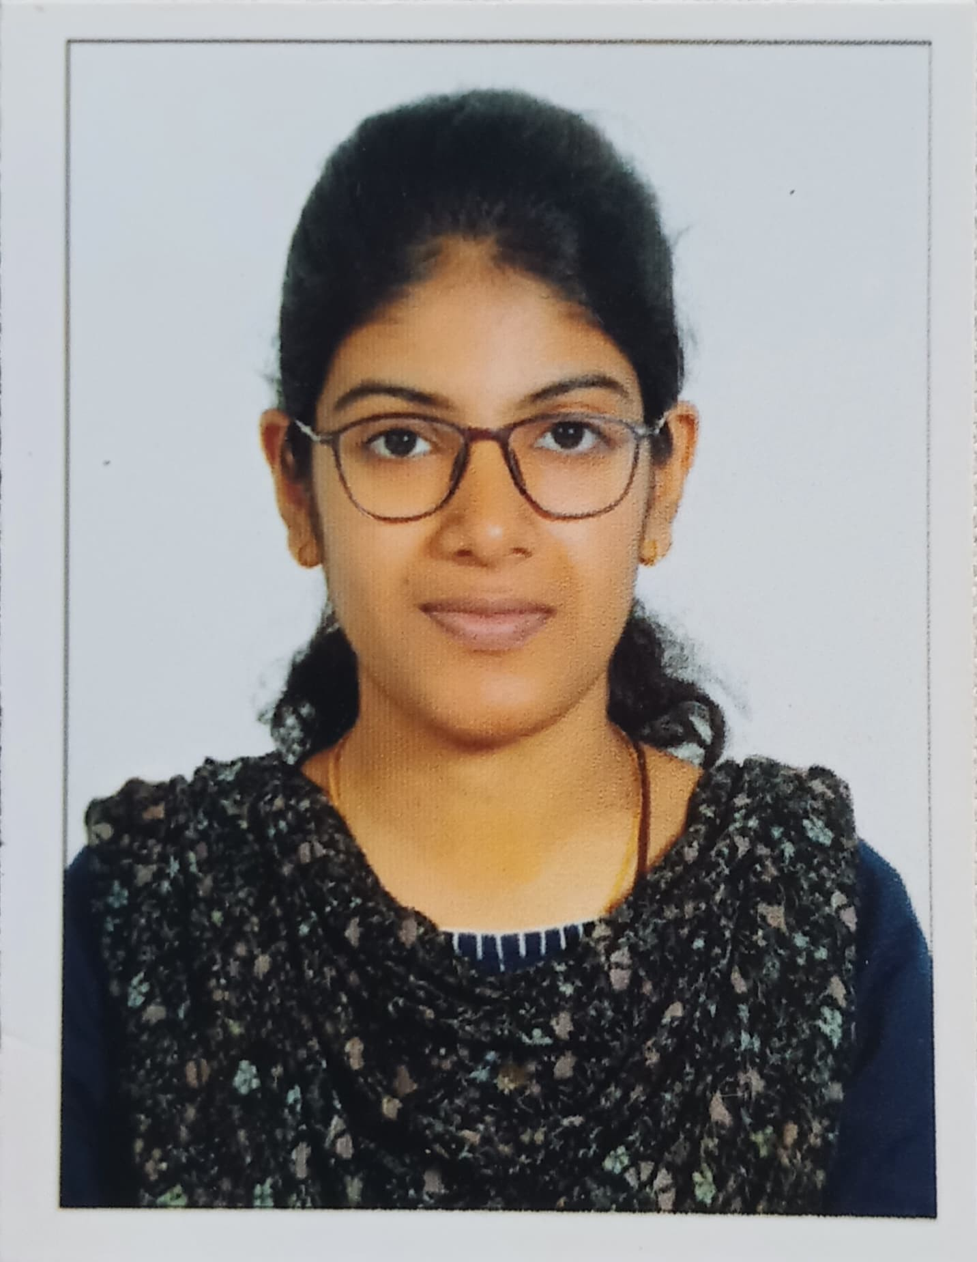
Navya Jolly

Mobile: +91 9633820121 • Email: navyajolly108@gmail.com

Location: INDIA, Kerala State, Alappuzha Dt, Pin: 688504

I’m a caring and compassionate radiographer who is seeking for an opportunity in the medical sector where I want to use my knowledge and talents for radiographic positioning and help the individuals in the area of health care while not compromising on the medical ethics and do the best to serve the diagnosed individuals and further advance myself in the field of radiology.

MACHINES HANDLED

OTHER MACHINES HANDLED

  - FUJI Film FCR CAPSULA 12

  - SIEMENS 1.5 Tesla MRI

  - AGFA DR

  - Allengers 500 mA X-Ray

  - 100 mA GE Multi Mobile Machine

PROFESSIONAL EXPERIENCE

- M.R.I Procedure : All kind of plain and contrast studies, M.R.A, M.R.V.

- Spiral CT Procedures : All kind of plain and contrast studies, Chest HRCT, Angiogram procedures like Cerebral Angiogram, Pulmonary Angiogram and Renal Angiogram.

- Routine Radiography : Conventional x-rays like chest, skull, extremities, spines, abdomen and contrast investigations like IVP, AUG, HSG, sinogram etc.

- Gastro-Intestinal Radiography: All barium procedures like Barium swallow, Barium meal series, Barium enema.
SKILLSETS

- Ability in managing polytrauma patients and handling emergency situations.

- Managing automatic processing films.

- Well versed in all MRI, CT & X-Ray techniques.

- Can do 3D reconstructions for both soft tissues and bones as well as produce best quality films.

- Can be a best individual within the team and cooperative.

- Hospital practices and patient care.

- Critical thinking and service oriented.

- Excellent communication and highly confident individual.

WORK EXPERIENCE

- Radiographer ( INTERNSHIP )
From April 2022 – April 2023
At Vivekanandha Medical Care Hospital, Tiruchengode, Elayampalayam, Tamil Nadu -637205, India

ACADEMIC CREDENTIALS

- Vivekanandha Medical Care Hospital - Allied Health Science, Namakkal, Tamil Nadu.
The Tamil Nadu Dr. M.G.R Medical University.
B.Sc. Radiology & Imaging Technology (2018- 2023)

- St. Joseph’s Higher Secondary School – Biology Science (STATE BOARD)(2016-2018)

- K.E Carmel School (ICSE BOARD), Kerala, Alappuzha (SSLC)-(2016)

REFERENCE

R. Suresh – Radiographer
Vivekanandha Medical Care Hospital, Namakkal
| +91 6379925029

KNOWN LANGUAGES

- ENGLISH
- MALAYALAM
- TAMIL
- HINDI

SELF DECLARATION

I hereby declare that the above information’s are true to the best of my knowledge.
[Navya Jolly]

