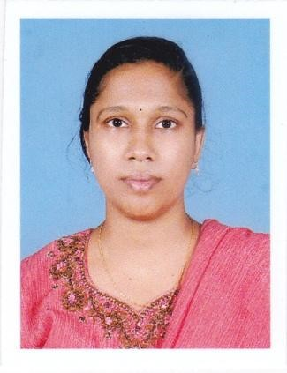
CURRICULUM VITAE

JOMOLE V T
Email:jomolejack2020@gmail.com

OBJECTIVES
Seeking a position as a nurse in areputed hospital where I can get learning environment along with using my skills and knowledge in patient care and being essential to the society.

PERSONAL PROFILE
Name | : | JOMOLE V T
Husband’s Name | : | Bidhan Banik
Mobile Number | : | 9048247712
Marital Status | : | Married
Religion | : | Christian
Natinality | : | Indian
Language proficiency | : | English, Malayalam & Hindi
Address | : | Vadodil House
 |  | Nayarambalam P O
 |  | Veliyathamparambu
 |  | Ernakulam 682509

ACADEMIC QUALIFICATION
SSLC passed with 46% during the year 1999-2000, St. Marys High School Niranam, Kerala.
Higher Secondary Examination passed with 51 % during the year 2000-2002,DBHSS Parumala, Kerala.

PROFESSIONAL QUALIFICATION
B.Sc Nursing with 60% during the year 2002-2017, hillside college of nursing Bangalore, [Rajiv Gandhi University of Health Science Karnataka]

PROFESSIONAL REGISTRATION
1. Registration | : Certification of registration for Nurses and Midwives
Authority | : The Karnataka Nurses and Midwives Council
Reg. No. | : 02N2418
2. Registration | : Certification of registration for Nurses and Midwives
Authority | : The Kerala Nurses and Midwives Council
Reg. No. | : 45596  PROFESSIONAL EXPERIENCE
1. Name of Hospital | : | SPATICA Super Speciality Hospital Bangalore, Karnataka.
Designation | : | Staff Nurse.
Area of Work | : | Accidents and Emergency Service, General Medicine,  General Surgery, Obsterics & Gynaecology, ICU (Medical  & Surgical), Operation Theatre, ENT
Duration of Work | : | 10.12.2007 to 30.12.2011
2. Name of Hospital | : | EVERSHINE Hospital Edappally, Kerala.
Designation | : | Staff Nurse.
Area of Work | : | Medical & Surgical Ward
Duration of Work | : | 15.02.2012 to 30.06.2014
3. Name of Hospital | : | EVERSHINE Hospital Edappally, Kerala.
Designation | : | Staff Nurse.
Area of Work | : | Medical & Surgical Ward
Duration of Work | : | 18.08.2016 to 15.02.2019
4. Name of Hospital | : | KARUNA Hospital MANJAPRA
Designation | : | Staff Nurse.
Area of Work | : | Medical & Surgical Ward
Duration of Work | : | 01.04.2019 to 23.11.2021
5.Name of Hospital : Starcare Medical Center Oman
Designation : Staff Nurse
Duration : 4.4.2022 to 23.4 2023
TYPE OF PATIENTS HANDLED
Myocardial Infarction
Hypertension
Stroke
Appendicitis
COPD
Haemorrohoid

EQUIPMENTS USED
Cardiac Monitor
Pulse Oxymeter
Infusion Pump
Defibrillator
Nebulizer,suction apparatus
Glucometer
ECG Machine

STRENGTHS
Self Confident
Good in Communication
Good in Presentation
Good understanding
Leadership
Capability and interest in utilizing every learning activities.

DECLARATION

I, Mrs. JOMOLE V T hereby submit these curriculum vitae for your kind consideration and for favorable orders. I declare that the information furnished above is true to the best of my knowledge.

Place : Nayarambalam
Date : JOMOLE V T

