KRISHNAPRIYA P.K.
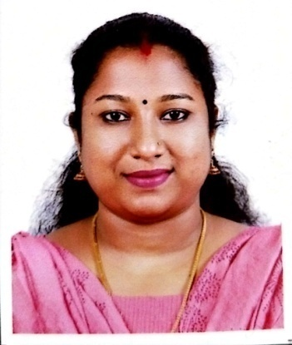 | Permanent Address  Suraj Bhavan,Plot no: 156  Jawahar Nagar  Kadavanthra p.o ,Cochin -20  Pin 682020  Contact - +91 7356938973  Email: krishnapriyapk35@gmail.com
CAREER OBJECTIVE
To work in a challenging environment with a scope of future progress. I would like to welcome the chance to work as a part of a dynamic working team where I could make a significant contribution while developing my skills yet further.
ACADEMIC QUALIFICATION
QUALIFICATION | INSTITUITION | YEAR OF PASSING | PERCENTAGE OF MARKS
S.S.L.C | St.Mary’s GHS Cherthala | 2009 | 87
Plus Two | St:Francis Assisi HSS,Arthunkal | 2011 | 67
B.Sc Zoology | St:Michael’s College Cherthala | 2014 | 77
M.Sc Zoology | S.D College, Alappuzha | 2016 | 62
HDC & BM | Co operative Training College, Cherthala | 2021 | 80

PERSONAL PROFILE
Father’s Name : M. T Krishnankutty
Mother’s Name : M.K Chandramathy
Date of birth : 05-04-1994
Gender : Female
Nationality : Indian
Maritalstatus : Married
Spouse’sname : Suraj .S
Languages Known : English , Malayalam

EXPERIENCE
I have the working experience of one year as a clerk in a cooperative society.
KEY SKILLS
- Excellent communication skill with fluency in English.
- Strong knowledge of utilizing all the modern teaching aids.
- Ability to handle children of different age groups.
- Expertise in using new teaching methodology to explain difficult topics.¬
- Ability to encourage talents of students.

DECLARATION
I here by , declare that all the statements in my Curriculum Vitae are authentic, complete and correct to the best of my knowledge and belief.

Place : Kadavanthra
Date : KRISHNAPRIYA P K

