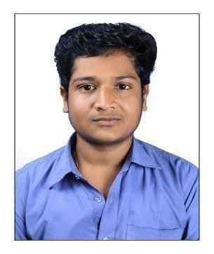Career Objective

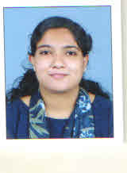

GEETHU ISSAC

Email:geethuissac1997@gmail.com

Address for Communication:
Kariyil house
Cherthala P O Cherthala
AlappuzhaKerala, Pin: 688524

Phone:
+91 9947313616,+7012449379

Personal Data

Father :K J Isaac
Mother :Thankamma
Date of Birth :24-March-1997
Place :Cherthala
District :Alappuzha
State : Kerala
Nationality :Indian
Languages-Known
Able to speak: English, Malayalam,
Able to write: English, Malayalam
Able to read: English, Malayalam.

To be the part of an organization where my skills can be applied effectively for the growth of the organization as well as to build up a challenging career. I intend to contribute positively towards the growth and prosperity of the company. I want to apply my business development skills to an environment where they will make a significant impact on the bottom line.

Personal Statement

Talented in Filing duties related with GST, TDS etc and a quick learner. Have much Computer skills in TALLY ERP, M S SOFTWARE, and Billing. Excellent in problem solving.

Key-skills and Management

Professional management skills
- Meeting objectives
- Motivating and developing staffs
- Excellent team building skills

Education

- Doing M.com in Finance at CAAM College of Accountancy & Applied Management Cherthala

- B.com Commerce with Computer Application with 69 % from Naipunnya School Of Management, Cherthala(2014-2017)

- Higher Secondary with 79% in Commerce from
Holy Family Higher Secondary School Cherthala (2012-2014)

- SSLC with 69% from St Mary’s G H S Cherthala

Technical Expertise
- Operating Systems : Windows 7 / 8 /10
- Applications & Tools : Tally.Erp9, MSOffice(all)

Working & Training Experience

- Job : Accounts Assistant
Firm : Jossy Thomas &co
Tax consultant
Place Cherthala , Alappuzha
Experience: Presently Working (from14/11/2017)
Reference : Jossy Thomas
jossythomasco@gmail.com Ph. +91 9446039662

MainProject
Website Development for National Coir Looms Pvt. Ltd. Alappuzha

Achievements

- . Organized VANQUISH, a Management Fest by Naipunnya school of management, Cherthala.

Declaration

I hereby declare that the above mentioned information is correct up to my knowledge and I bear the responsibility for the correctness of above mentioned particulars.

Date :
Place : Geethu Issac

