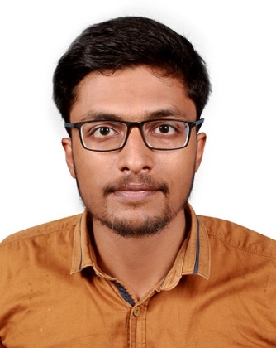
DR. EDWIN GEORGE PULLAN
KODAKARA , THRISSUR
+918848628184
edwingeorge50@gmail.com
Registration No. 87868

Summary
MBBS graduate with one year of experience working as an intern in various departments including super specialty department. Excited to work in a hospital setup as I constantly strive to increase my capabilities as a clinician through exposure to different cases and various clinical scenarios.
Education
Exam | University/Board | Institution Name | Passing Year | Result/  CGPA
M.B.B.S | Deemed University Maharashtra | Krishna Institute of Medical Sciences | 2021 | 64.3%
12th | Central Board of Secondary Education | Delhi Private School Dubai | 2016 | 93.4%
10th | Central Board of Secondary Education | Delhi Private School Dubai | 2014 | 8.6

Experience
- Assisting senior doctors of various departments in monitoring patient’s status.
- Diagnosing based on patient’s signs and symptoms.
- Performing routine clinical procedures.
- Giving basic treatment in case of emergency.
- Served in Covid ward and ICU.
- Assisting Consultants and senior residents while performing C-section.

Achievements
- Presented seminar in the subjects of Anatomy and Forensic Medicine and Toxicology.
- Participated in Survey organized by the department of Community Medicine in the locality to find out the number of people vaccinated against Covid infection and if not, the reasons for not doing so.
- Received letter of appreciation for my service in Covid wards and ICU.

Strengths
- Hardworking and a team player.
- Good communication skills.
- Able to adapt as situation changes.
Personal Information
- Date of Birth : 23/10/1998
- Language Proficiency : English , Malayalam , Hindi
- Marital Status : Single
- Hobbies : Swimming , Travelling , Documentaries.

