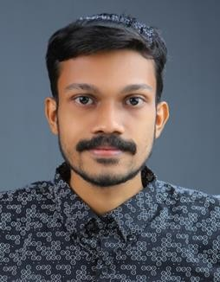
BERIN V. B.
Vazhappillykudy House Thuruthy P. O. Thuruthy
Ernakulam Dist. Kerala - 683545
Mob: 9048291500
E-mail: berinvb30@gmail.com

PERSONAL DETAILS

Name : Berin V. B.
Fathers Name : Baby V. K.
Gender : Male
Date of Birth : 30/01/1996
Marital Status : Single
Religion : Christian
Caste : Jacobite
Nationality : Indian
Languages Known : Malayalam, English, Hindi

EDUCATIONAL QUALIFICATION

Qualification | Name of Institute | Board/University | Year of Passing
SSLC | Mar Augustine HSS Thuravoor | Kerala State Board of Public Examination | 2012
Plus Two | MGM HSS Kuruppampady | Board of Higher Secondary Examination  Kerala | 2014
Degree | St. Kuriakose College of Management And Science Kuruppampady | MG University Kottayam | 2017
PG (M.com) | St. Kuriakose College of Management And Science Kuruppampady | MG University Kottayam | Result waiting

PROGRAMME SKILLS

Diploma in Indian and Foreign Accounting, MS Office

EXPERIENCE

- 2 Year Experience as a Accounts and branch executive in Kosamattam Finance Ltd.
- 1 Year experience as a Accounts with front office executive in ASAP Community Skill Park, Perumbavoor

DECLARATION

I solemnly declare that all the Statement above are true and correct to the Best of my knowledge and belief.

Berin V B

Date : Place :

