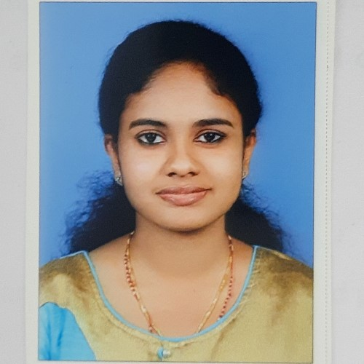
RAISA SHAJU
KOTTAKKAL (H) KOONAMMAVU P.O,
7994542559, smariaraisa23@gmail.com

SUMMARY
I completed my Bachelor’s degree in Microbiology and completed my masters in Hospital Administration (result waiting) with hospital exposure through 2 academic projects.
OBJECTIVE
As a fresher, I am seeking a role which allows me to continue learning and perfecting my skills as I provide high-quality work, and encourages me to flourish as a good human being.
EXPERIENCE
I consider myself a responsible and orderly person, looking forward for my first work experience.
QUALIFICATION
MASTER’S IN HOSPITAL ADMINISTRATION (Result waiting)
LIMSAR, ANGAMALY
KERALA UNIVERSITY OF HEALTH SCIENCES
BSC. MICROBIOLOGY
MES COLLEGE MARAMPALLY
MAHATMA GANDHI UNIVERSITY
SKILLS
Good Communication
Computer skill: - Spreadsheet, MS Word, Slide Presentation
Critical Thinking and Problem solving.
PROJECTS
Academic project 1: A study on physical facilities, policies and procedures of pharmacy department in Lourdes Hospital, Ernakulam.
Academic project 2: A study on the ascertainment of patient identification in Aster Medcity, Kochi.
INTERESTS
Travelling
Cultural and Spiritual activities.
REFERENCE
RESHMA RAJAN
Assistant Professor, LIMSAR
Reshmarun17@gmail.com
PERSONAL INFORMATION
Date of Birth : 23-12-1999
Nationality : INDIAN
Father Name : SHAJU K.P
Gender : FEMALE
Marital Status : SINGLE
Language Known: English, Hindi, Malayalam
I hereby declare that all above information is in correct with fact or truth up to my knowledge and I bear the responsibilities for the correctness of the above-mentioned particulars.

Date: 21/02/2023 RAISA SHAJU

