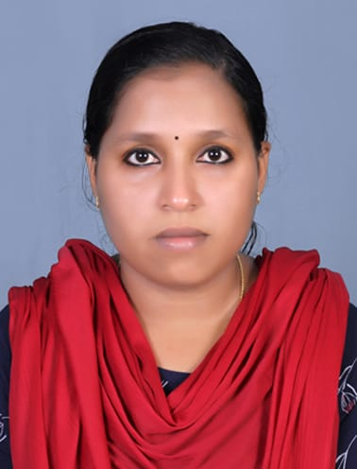
Kavyamol Unni
Kavyaunni00@gmail.com
7593940720

Professional Summary | Motivated customer service specialist with 2.4 years of experience in a fast–paced, team based environment. Patient and empathetic with extensive background in conflict resolution and customer care . Skilled in training staff and establishing a rapport with clients. Self motivated with exceptional communication and computer capabilities.

Work history | September 2015-January 2018  Sutherland Global Services  Process Associates  - Met monthly KPI’s and got positive reviews for excellent customer service  - Was working in the customer support of DU Telecom  - Helped drive sales goals and achieve monthly quotas  - Achieved sales goals and service performance requirements through new customer sales

Education | 2015 MG University  BA Economics

Personal Details | Age & DOB | : | 28 yrs, 9th July 1994
 | Gender | : | Female
 | Address | : | Ponnachuparambil house  Ayyampilly P O  Kuzhuppilly  Ernakulam  Pin : 682501
 | Languages known | : | English, Malayalam
 | Marital status | : | Married
 | Nationality | : | Indian

Declaration
I hereby declare that the above mentioned information is correct up to my knowledge and I bear the responsibility for the correctness of the above mentioned particulars.

Place : Ernakulam Kavyamol Unni
Date:

