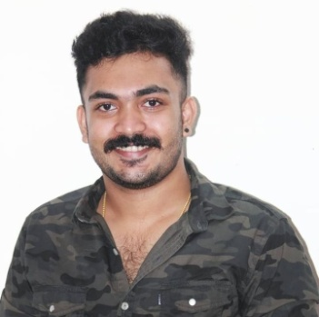
RESUME
ABY MICHAEL
KATTOOPARAMBIL HOUSE
NEENDOOR P O
KOTTAYAM- 686601
Mob: +91 9446271291, +91 9526056905
Email: abymichael1096@gmail.com

CARRIER OBJECTIVE
To work with an organization which give me an opportunity to utilize my education and knowledge. Where I can prove my capabilities for professional growth.
PERSONAL DETAILS
Name : Aby Michael
Father’s Name : Michael Joseph
Date of birth : 10/09/1996
Age : 26
Gender : Male
Nationality : Indian
Marital status : Single
Religion : Christian
Languages Known : English, Hindi, & Malayalam

WORK EXPERIENCE
- Revathy Medical Center, Tamilnadu
- Clinical Trainee MRI Scan
X Ray, CT Scan (3years)
EQUIPMENT HANDLING
- Toshiba
- GE
- Hitachi 128 slice

ACADEMIC QUALIFICATION
COURSE | BOARD | INSTITUTION | YEAR OF COMPLETION
SSLC | Board of Public Examination in Kerala | St. Thomas H S S , Kallara | 2011
Plus Two | Sangai International University Manipur | Nalanda Institute,  Jaipur | 2016
B Sc. Radiology | Sangai International University Manipur | Nalanda Institute,  Jaipur | 2019

DECLARATION
I hereby declare that all the information is true and correct to the best of my knowledge and belief.

Place: Neendoor ABY MICHAEL

