**RESUME**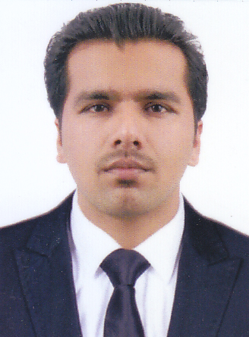

**CLINTON BABY**

Kalarikal House

Sasimala Post

Pulpally

Wayanad, 673579 Mobile : +91 7507051955

Email: cbkbaby8@gmail.com





Seeking a job in CT Scan Technician, where I can excuse it with all the responsibility to the very best of my ability with a desire to grow along with a Progressive Organisation.



| **S.NO** | **NAME OF EXAMINATION** | **BOARD/ UNIVERSITY** | **YEAR OF PASSING** | **PERCENTAGE** |
| --- | --- | --- | --- | --- |
| **1** | **Diploma in CT Scan & X-Ray** | **Chennai** | **2016** | **78.08** |
| **1** | **Plus Two (Commerce)** | **National institute of open School** | **2020** | **74.2** |
| **2** | **SSLC** | **Board of Kerala Education** | **2008** | **65.38** |



* **MS Office**



* **Excellent interpersonal communications skill.**
* **Highly adaptive to any working condition & flexible.**
* **Total commitment towards work.**
* **Self-motivated & Self-Learner**.
* **Leader ship**
* **Good Communication skill**
* Playing Cricket
* Reading books
* Driving



Name : Clinton Baby

Father’s Name : Baby

Date of Birth : 27/04/1993

Sex : male

Marital Status : Single

Nationality : Indian

Religion & Caste : Christian, Jacobite



**To Read To Write To Speak**

English ✔ ✔ ✔

Malayalam ✔ ✔ ✔

Hindi ✔ ✔ ✔

Marathi ✔ ✔ ✔

Tamil ✔



* 1.5 Years experience in CT Scan Technology at Sai Scan Center, Yeola, Nashik, Maharashtra.
* 1 year experience in X-Ray Technology at Santhoshimata Hospital Yeola, Nashik, Maharashtra

.



I hereby declare that the above mentioned all details are true in best of my knowledge and belief.

Place : Pulpally

Date : **CLINTON BABY**