CURRICULUM VITAE

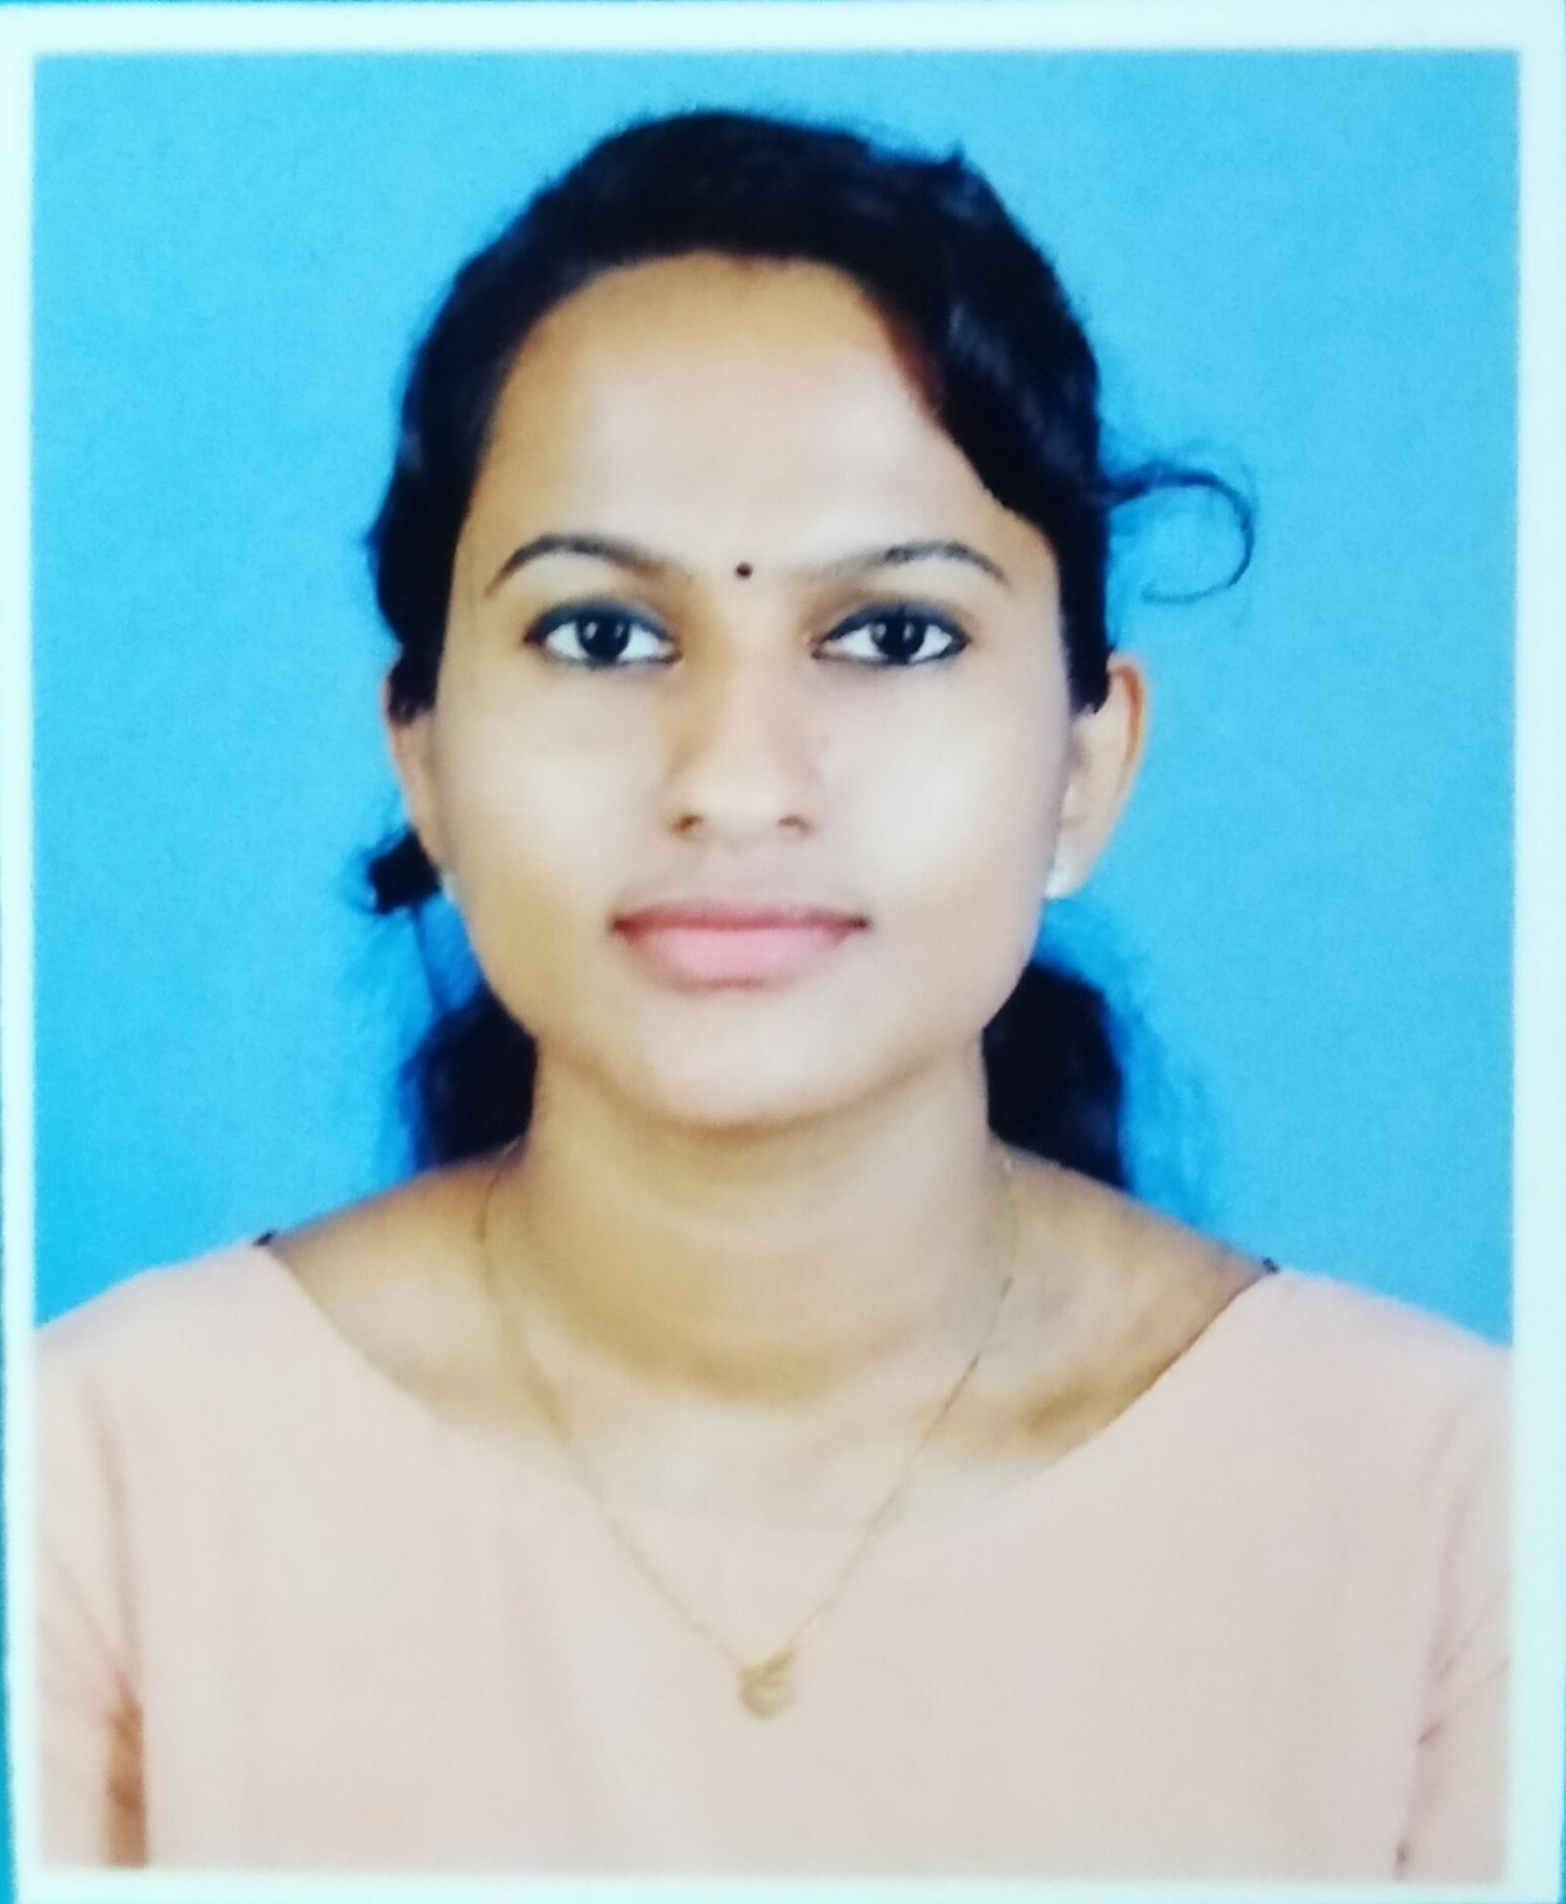
JEENAMOL CHERIYAN
VELLAMATTATHIL (H)
MUNDANMUDY P.O
IDUKKI DIST - 685607
KERALA, INDIA
MOB: 9496790458,7306804159
EMAIL: jeenamolcheriyan7@gmail.com

CAREER OBJECTIVE
TO OBTAIN A POSITION IN A HEALTH CARE FACILITY WHERE I CAN UTILIZE MY SKILLS, KNOWLEDGE AND EXPERIENCE TO PROVIDE QUALITY HEALTH CARE

PERSONAL DETAILES
FATHER NAME: CHERIYAN JOSEPH
DATE OF BIRTH: 07/06/2000
NATIONALITY: INDIAN
RELIGION: CHRISTIAN
MARITAL STATUS: UNMARRIED
LANGUAGES KNOWN: ENGLISH, MALAYALAM, TELUGU

EDUCATION AND PROFESSIONAL CREDENTIALS
QUALIFICATION | BOARD | YEAR | PERCENTAGE
SSLC | SREE NARAYANA MEMORIAL VHSS  VANNAPPURAM | 2015 | 82%
PLUS TWO | ST.MARY’S HSS  KALIYAR | 2017 | 79%

ACADEMIC QUALIFICATION
QUALIFICATION | BOARD | YEAR | PERCENTAGE
BSC NURSING | ST.ANN’S COLLEGE OF NURSING | 2022 | 1ST CLASS

PERSONAL SKILLS
- COMPASSIONATE APPROACH TOWARDS PATIENT CARE.
- ALWAYS READY TO SAFEGUARD AND PROMOTE THE WELLBEING INTEREST OF PATIENT.
- INTERACT AND COMMUNICATE WITH PATIENT OF ALL AGES AND ETHNIC BACKGROUND, GIVING QUALITY MEDICAL CARE AND TREATMENT.
DECLARATION
I HEREBY DECLARE THAT THE ABOVE MENTIONED INFORMATIONS ARE CORRECT TO THE BEST OF MY KNOWLEDGE AND THE NOTHING HAS BEEN CONCEALED.

PLACE: MUNDANMUDY
DATE: 28/07/2022 JEENAMOL CHERIYAN

