CURRICULAM VITAE

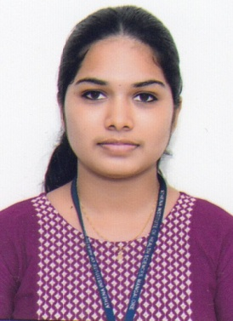
Name: Anju Joseph
Address: Villanthanathu, Moonnilavu P O. Moonnilavu, Kottayam, Kerala
Contact Number: +91 8590038993
Email: anjujv1999@gmail.com

Educational Qualifications
Title of Qualification: BSC Nursing
University: RAJIV GANDHI UNIVERSITY OF HEALTH SCIENCE, BENGALURU
Institution: Athena College of Nursing
Language: English, Kannada & Malayalam
Years of Study : October 2017 to December 2021

Professional Registration
Karnataka State Nursing Council, Karnataka
Registration Number: 124243

Employment/Work Experience

Date of employment: June 20th 2022 to
still working
Name of Hospital: Marian Medical Centre City/State: Pala/Kerala
Job Title/Designation: Staff Nurse

Department/Ward Allocation: Medical and Surgical ward Nurse patient ratio: 1:8

Most Common Cases Handled
- COPD
- CAD and CKD
- PNEUMONIA
- ARDS
- TUBERCULOSIS
- OSTEOARTHRITIS
- HERNIA
- APPENDICITIS
- FRACTURES
- PULMONARYEDEMA etc

Duties And Responsibilities
- Assessing physical, psychological needs of the client, collection of personal, social, medical and general data by interviewing formally and informally during various nurse client interactions, observations, review of records, diagnostic tests etc.
- Patient education and education of the relatives.
- Providing overall care to the patient. Explaining about the procedure and giving rational.
- Monitoring fluid and electrolyte balance, administering intravenous fluid and medications, monitoring and maintaining adequate record intake and output, sending blood samples for investigations.
- Administering drugs through various routes.
- Documenting all relevant informations.
- Meeting nutritional and elimination need.
- Preparing patients for various investigations.
- Supervision of juniors and non professional workers.
- Nursing process in assessing planning, implementation and evaluating daily individual patient care.
- Maintaining good interpersonal relationship with patients and their family members.

Gaps in Employment

January 2022 to June 2022 – OET preparation

Personal Profile
Name : Anju Joseph
Date of birth : 16/10/1999 Gender: Female
Marital status : Single Religion/caste : Christian, R.C.S.C.
Nationality : Indian
Languages known: English,
Kannada
& Malayalam
Personal Interests: Reading,
Drawing
Passport no : V6823657
Date of issue : 02/03/2022
Place of issue:Cochin
Date of expiry :01/03/2032

Employment References
Name: Sr. Jincy FCC
Organisation: Marian Medical Centre Arunapuram, Pala Job Title: Nursing Superintendent
Contact Number: 0482-2214000,
Email id : marianmedicalcentre@yahoo.com

Name : Sr. Blessy Jose FCC
Organization : Marian Medical Centre Arunapuram, Pala Job Title : Nursing Superintendent
Contact number : 0482-2214000
Email id : marianmedicalcentre@yahoo.com

Declaration
I hereby declare that this Curriculum Vitae is true and correct. DATE: 07/12/2022
LOCATION: Moonnilavu
Name : Anju Joseph

