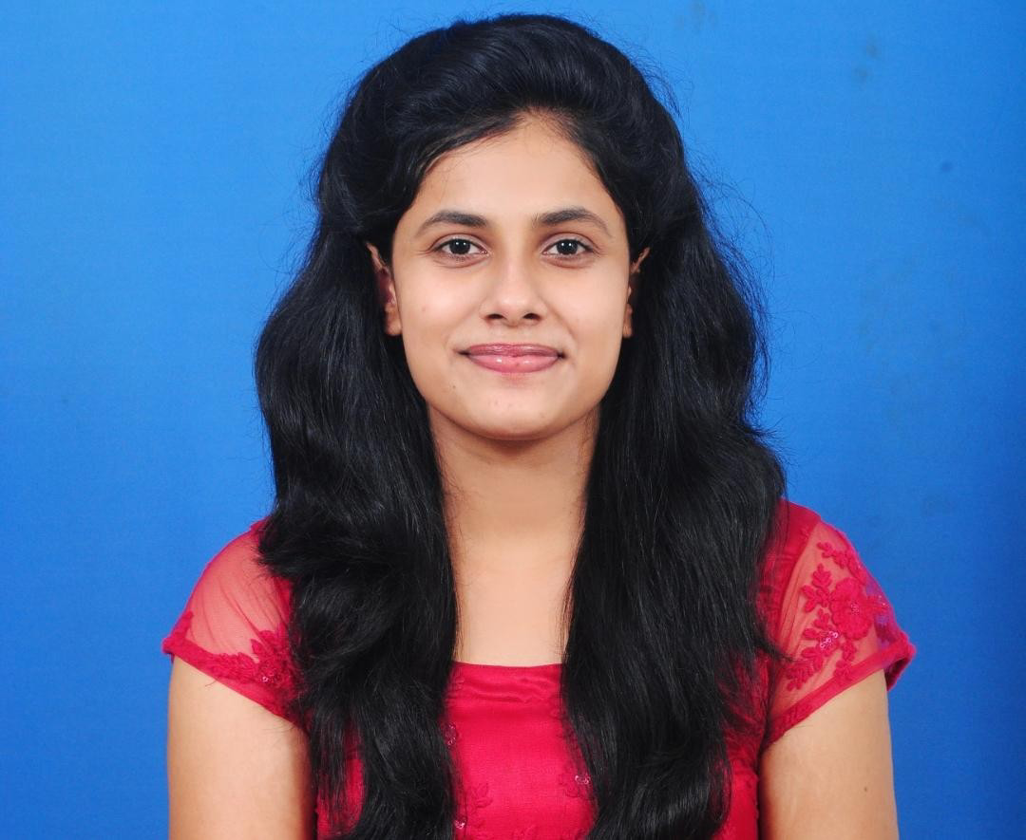
SHEBA S THOMAS KERALA,INDIA
Mob: +91 7907599267
Email: shebasthomas00@gmail.com

Bachelor of Science in Nursing – 2021
India Licensed Registered Nurse studied in Manipal College of
Nursing, Manipal, P.O. Box: 7, Manipal, Karnataka-576104, State- Karnataka, India - Reg. No-118224

OBJECTIVES:
To achieve a challenging position in a progressive environment that utilizes my professional and communication skill and provides ample opportunities for growth.

PROFESSIONAL EXPERIENCE:

KASTURBA HOSPITAL (KH), P.O Box: 7, Manipal, India .

(NABH Accredited, ISO 9001:2008 certified) (2050 Bed strength)
Performed clinical duties in various subjects:
- Fundamentals of nursing:450 hours
- Medical surgical nursing(adult including geriatrics)-1:720 hours
- Community health nursing-1:135 hours
- Medical surgical nursing(adult including geriatrics)-2:270 hours
- Child health nursing:270 hours
- Mental health nursing:270 hours
- Nursing research and statitics:45 hours
- Geriatric Nursing:40 hours
- Midwifery and obstetrical nursing:180 hours
- Community health nursing-2:135 hours Integrated practice(internship)
- Midwifery and obstetrical nursing:180 hours
- Community health nursing-2:195 hours
- Medical surgical nursing(adult including geriatric):430 hours
- Child health nursing:145 hours
- Mental health nursing:95 hours

DUTIES PERFORM:
- Assessment, planning, intervention, implementation & evaluation
- Observing change in client’s condition, recording & reporting to the concerned authority and taking necessary action immediately.
- Early identification and prevention of complications..
- Maintaining effective gas exchange and tissue perfusion.
- Maintaining normal fluid electrolyte & acid base imbalance.
- Maintaining all infection control measures.
- Maintaining clean and safe environment for the patients.
- Maintaining high standard in preparation, calculation, cross-checking and administration of medication as per order.
- Giving health education to the Clients
- Keeping the unit clean and tidy and care of all equipments of patient unit.
- Preparing articles and patients for medical, surgical or nursing procedures.
- Assisting doctors in various medical and surgical procedures.
- Continuous cardiac monitoring and monitoring vital signs.
- Ward management, co-operation and co-ordination with other co-workers.
- Assist with management of acute emergencies like cardiac and respiratory arrest and carrying life saving procedures like cardio pulmonary Resuscitation, Defibrillation and cardio version. • Assist in procedures like Bronchoscopy, CVP insertions, Arterial Line insertion.

EDUCATIONAL QUALIFICATION:

Professional: B Sc. Nursing from Manipal Academy Of Higher Education, Karnataka

Institution: Manipal College of Nursing, MANIPAL ACADEMY OF HIGHER EDUCATION Karnataka (State), India. Year of 2018-2022.
(Reg. No.180501040).
Year | Institution | Percentage of marks
First year | Manipal College of Nursing, Manipal Academy of Higher Education, Manipal | 72%
Second year |  | 74%
Third year |  | 74%
Fourth year |  | 72%
Consolidated |  | 72%

Registration Details:
- Karnataka Nursing Council.
Registration number: 130181

Qualification | Board | Year of passing | Percentage of Marks | Score
PUC (XII)  (Reg. No- 4805995) | CBSE | 2018 | 69.00% | Pass
SSLC (X)  (Reg. No-6105464) | ICSE | 2016 | 78.00% | Pass

PERSONAL PROFILE:
Date of Birth : 17th March ,2000
Sex : Female

Marital Status : Unmarried
Fathers Name : Samkutty Thomas
Mothers Name : Rosamma Samkutty Nationality : Indian
Languages Known : English, Malayalam, Kannada.

PASSPORT DETAILS:

Passport Number : S1904488
Place of Issue : TRIVANDRUM
Date of Issue : 02/07/2018
Date of Expiry : 01/07/2028

Dr Anjalin D'souza- Manipal College ofNursing
Assistant Professor
Department of Child Health Nursing
anjeline.d@manipal.edu
+91 98453 78098

Mrs Pratibha - Manipal College of Nursing
Assistant Professor
Department of Obstetrical and Gynaecological Nursing
Pratibha.prakash@manipal.edu
+91 99640 25177

DECLARATION
I declare that the information furnished above is true and correct to the best of my knowledge and belief.
SHEBA S THOMAS
KERALA
Date: 02/07/2022

