RESUME

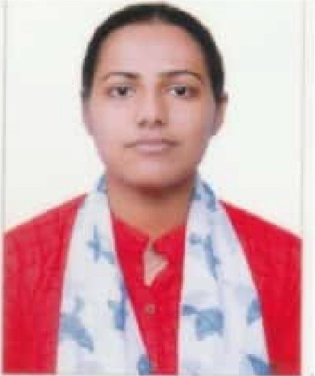
ANUMOLKJ
KoottaJa House
Kodanadu PO, Kurichilakkodu Perumbavoor, Ernakulam Kerala - 683544
Ph:9847275251
E-Mail id: anumolkjl 999@gmaiJ.com

OBJECTIVE
Seeking chalJenging opportunities as a nurse where I can utilize, apply my skills and knowledge to the institution and work directly with them to provide routine treatment and handle day to day interventions and analysis.

PERSONAL DETAIL
Father's name Mother's name Date of birth Nationality Marital status Gender Language known Extracurricular

Joshy KP ShinyJosby
08 February 1999
Indian Single Female
English, Malayalam, Hindi
Stock management activities ward management, Reading, & Attending conferences

QUALIFICATIONS
- B Sc Nursing from Usie College of Nursing, Ernakulam in the year 2022
Plus Two from St.Thomas Higher Secondary School, Malayattoor in the year 2017, BS%
- SSLC from Baselius Augen Public School, Kodanadu in the year 201s, 98%

PROFESSIONAL QUALIFICATIONS

Course | Institute/ Board | University | Reg No | Batch | Year of  Passing
B Sc Nursing | Lisie College of Nursing, | Kerala University of Health and | KL 03202204825  Mark Obtained : | 2017-  2022 | 2022
 | Ernakulam | Science | lstYear 63%  2nd Year 64%
3rd Year 63%
4th Year 68%

TRAINING
- Helping doctors in cbecki-□g the patient.
- Performing basic check up like vital signs, weight etc.
- Attending patient's need based treatment like personal care, medication administration etc.
Daily patient checkup
- Attending patient's in ICU and wards.

PERSONAL SKILLS
- Good in communication and interpersonal skills.
- Self-motivated and hard working
- Confident
Adapti-□g to changing circumstances
- Able to take the responsibilities
- Learning from failure
- Positive attitude
- Good listener
- Punctual
- Patience

RESEARCH DETAILS
A study to assess the effectiveness of structured teaching program on knowledge and practice regarding the prevention of life style disease among selected college students at Ernakulam District.

DUTIES & WORKS CARRIED OUT IN A PROFESSIONAL COURSE
Fundamental Nursing - Lisie Hospital, ErnakuJam Medical Surgical Nursing - Lisie Hospital, Ernakulam
- Mental Health Nursing - Government Mental Health Hospital, Thrissur & Kusumagiri Mental Health Centre, Kakkanad.
Child Health Nursing- Lisie Hospital, Ernakulam & District Hospital, Aluva
- OBG Nursing- W&C Hospital, Mattancherry & Lisie Hospital, Ernakulam Community Health Nursing- CHC, Koonarnmavu & CHC, Edappally.

EXPERIENCE
Practice as an intern in wards, ICUs (MICU, NICU, NSICU, NMICU, SICU, Nephro ICU, MDICU, CT-ICU & CCU), Recovery, Labour Room, OT and Casualty. Name of the hospital - Lisie Hospital, ErnakuJam

EQUIPMENTS USED
- Cardiac monitors with central monitoring system
- ECG machine
Sphygmomanometer, Pulse Oxi-meter, Thermometer
- ABG machine
- Glucometer
Syringe pump, Infusion pump
Nebulizer
- Ventilator

CAPABLE OF ASSISTING THE FOLLOWING PROCEDURE
- Intravenous Catheterization
- ICD insertion Lumbar puncture
- Dialysis
- Insertion of epidural catheter

DECLARATION

I hereby declare that all the information given above is true to the best of my knowledge and belief.

Place: Date :
ANUMOLKJ

