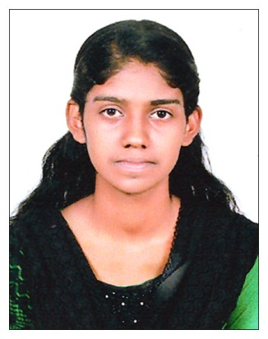
RESUME

ANAKHA DOMINIC
POONTHRASSERIL HOUSE
KATTOOR P O
KALAVOOR
ALAPPUZHA – 688522
MOB : 7736443449
Email : anakhadominic@gmail.com

PERSONAL PROFILE
Father’s Name : Dominic Michael
Date of Birth : 20/04/1998
Age : 24
Place of Birth : Alappuzha
Gender : Female
Marital Status : Single

WORK EXPERIENCE
7Months Account Assistant In GLOBAL ASSOCIATES.
Experience of working with Tally ERP
Good Knowledge of all Microsoft Office Applications. Specifically Excel and Word.
- Maintaining receipt and payment Voucher.
- Maintaining Purchase and Sales Entries. Banking and Journal entry
- Payment follow ups, Preparing Quotations and Cash Management.

ACADEMIC QUALIFICATION
Qualification | Institution | Board / University | Year of Passing | Percentage of mark
M.Com  ( Finance ) | Neelima College Alappuzha | MG University | 2022
B.Com  ( Computer  Application) | S N College  Mankombu , Alappuzha | MG University | 2018 | 64%
PLUS TWO | GRFTHS & VHSS  Arthunkal | Board of Vocational Higher Secondary Examination ,  Kerala | 2015 | 75%
SSLC | Holy Family H S S Kattoor | Board of Public Examination,  Kerala | 2013 | 72%

ADDITIONAL QUALIFICATION
- Diploma in Financial Accounting ( Tally ERP 9 ) - 6 Months
- Data Entry ( Microsoft Office ) - 6 Months

LANGUAGES KNOWN
- Malayalam : Read , Write & Speak
- English : Read , Write & Speak
- Hindi : Read & Write

DECLARATION
I hereby declare that above said information is true for the best of my knowledge.
Date :
Place : ANAKHA DOMINIC

