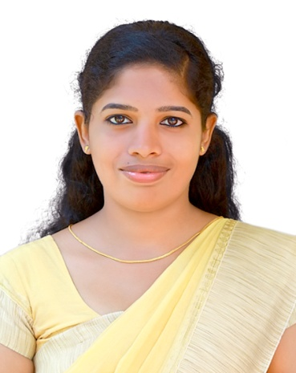

2019-2021 Volunteering Journeys, Fort Kochi,

Education Co-ordinator

**GIFTY MATHEW**

**Objectives**

**EDUCATION**

**WORK EXPERIENCE**

Seeking a good career with an organization of good work culture and reputation, which demands the best of my professional capabilities and which can really guide me in broadening and enhancing my current skills and knowledge to the best possible level. There by contributing myself to the growth of organization.

2015-2017

Master ofSocial Work

2012-2015

2010-2012

Bachelor of Arts in English

Plus Two

Rajagiri College of Social Sciences (Autonomous), Kalamassery

Baselios Poulose II Catholicos College, Piravom

St. Mary’s Higher Secondary School Morakkala

2018-2019

Duncan Academy, Raxaul, Bihar (CBSE)

Counsellor cum Teacher

**CONTACT**

**SKILLS**

**Languages**

giftymathew92@gmail.com

+91 8330810426

+91 7736542051

Palathinkal (H). Kadayiruppu P.O, Ezhipuram, Pin: 682311

2009

SSLC

Government High Secondary School, Kadayiruppu

**INTERNSHIPS**

RajagirioutREACH

Karunalayam Old Age home Thrikkara

Trinity Retirement Home Kolenchery

Mayasadan Orphanage Nepal

Integrated Child Development ServicesVadavucode

Group work

Case work

Rapport building

Effective communication

Adaptability

Time Management

Handling Pressure

Organizing

Malayalam

English

Tamil,

Hindi

**DOB: 26/12/1992**